Post-Flood Eval December 2025
By Regina Fletcher
What went well:
SVPA coordinated a dedicated 16 hour shift for the flooding event with four staff members, and communicated fixable issues throughout flooding event
Web/app developer Dave Sanderman was able to fix bugs during the flooding event as they appeared on our website and phone app versions
Highly visible gauges such as 124th west and 124th east captured flooding data during the event
Newly purchased gauges read distances well, and the thingsstack and milesight gateways performed well
What didn’t go well:
Some gauges and equipment were not high enough for this amount of flooding and were inundated and therefore didn’t capture all the water levels throughout the flood.
We were charged more than expected with Plivo and Google Maps API (around $500)
There were major gaps in readings and prediction data, some caused by unknown reasons which caused emails and phone calls from the public inquiring what was wrong
A total of three gauges were off during the majority of the flooding event (SVPA-26, SVPA-6, and SVPA-6B)
USGS predictions were off by 10s of thousands of CFS and SVPA could have followed up with them post-flood
NWRFC Prediction Details
Examples of progression up to a flooding event, showing the changes in prediction in both CFS and height. Dozens of flood predictions came in between November 30th and up until the high peak event around December 11th. The following is more information on the Carnation Gauge as it helps the most with planning for the Floodzilla Gauge Network.
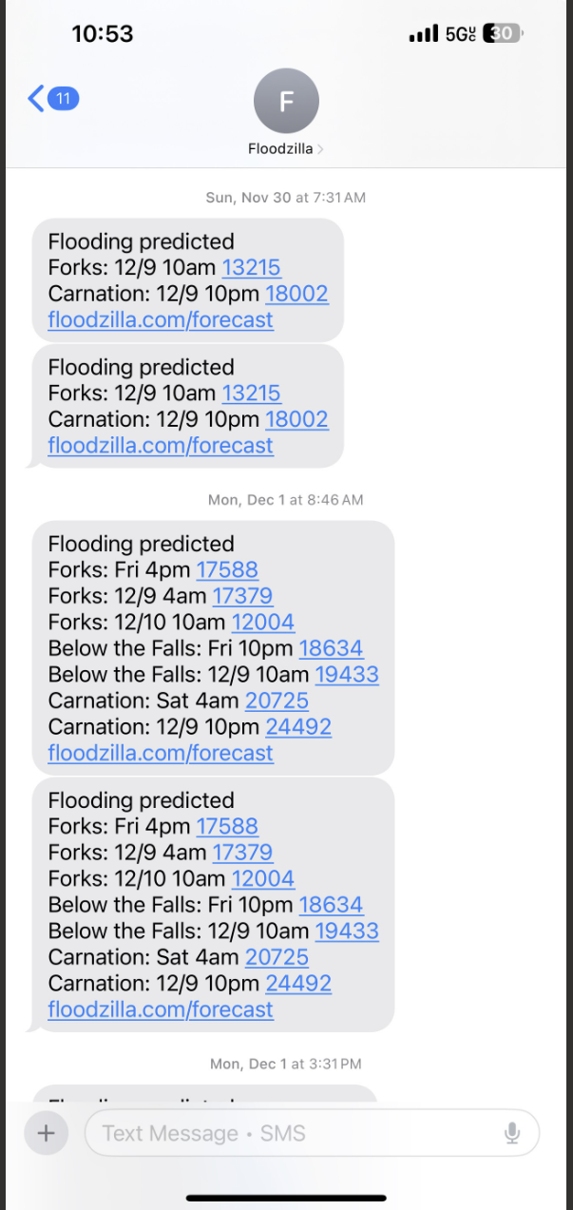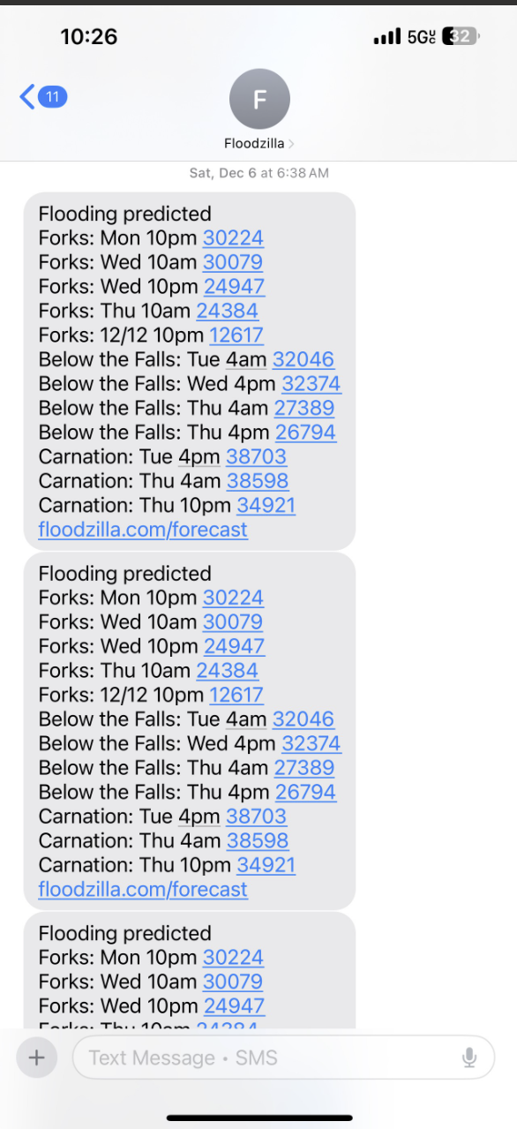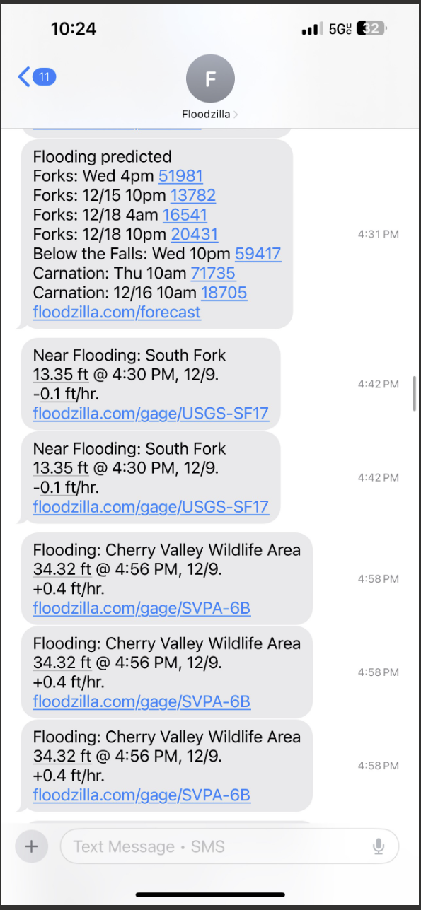
First associated flooding prediction for December on November 30th (left), December 6th 2025 Screenshot (middle) and December 9th 2025 Screenshot (right).

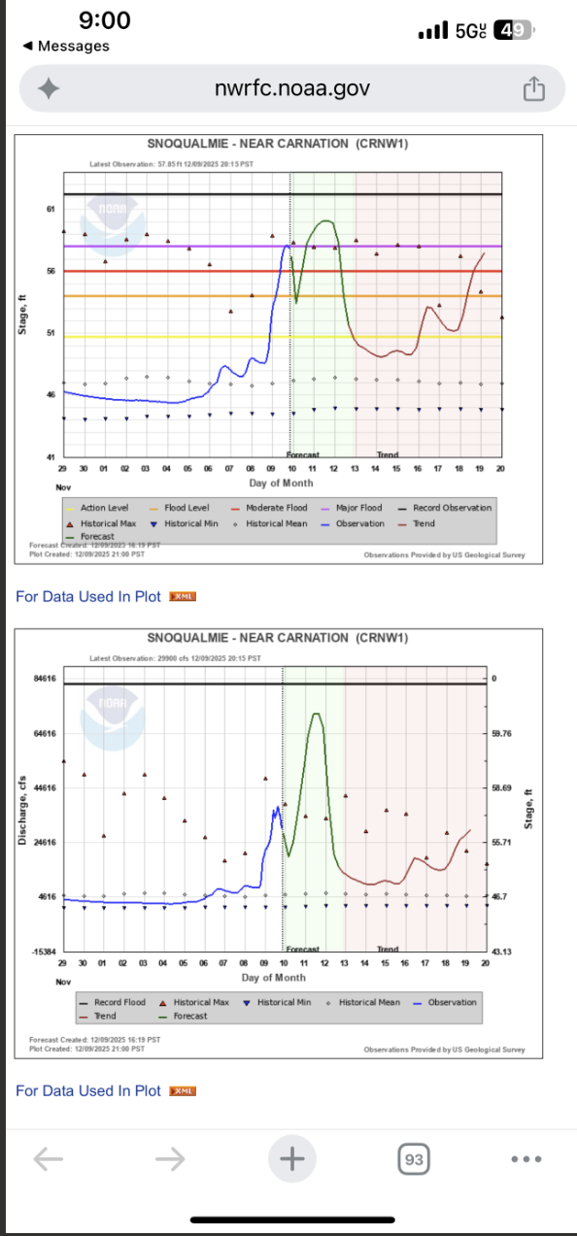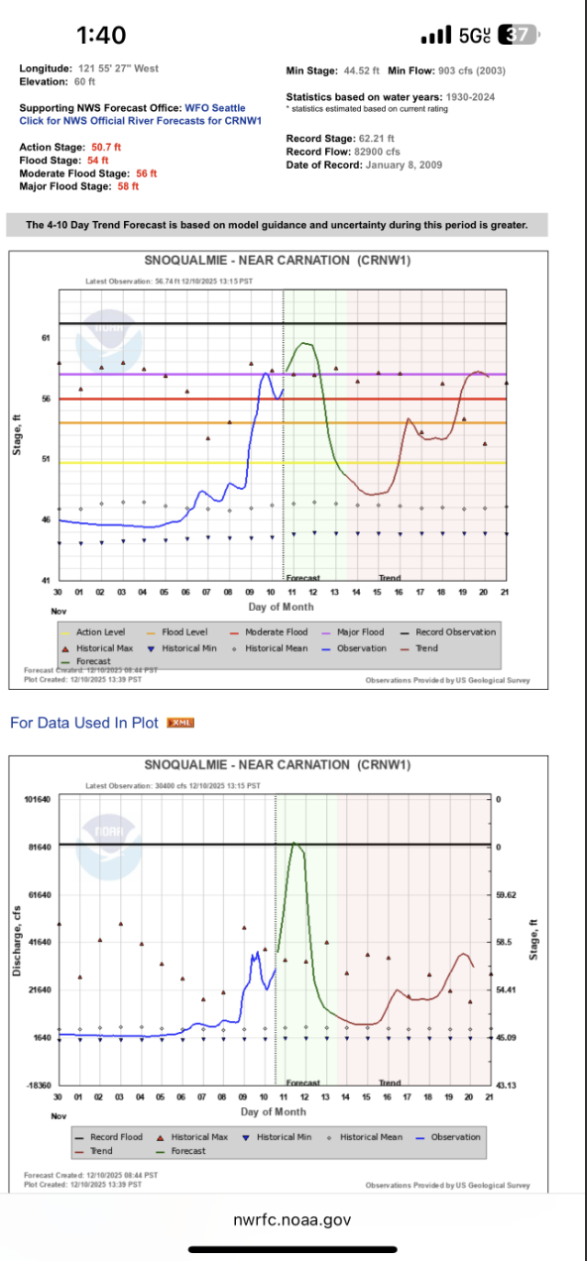
December 9th 2025 9pm Screenshot (left) corresponding with the 4:30pm prediction that day, and December 10th 2025 1:40pm Screenshot (right).

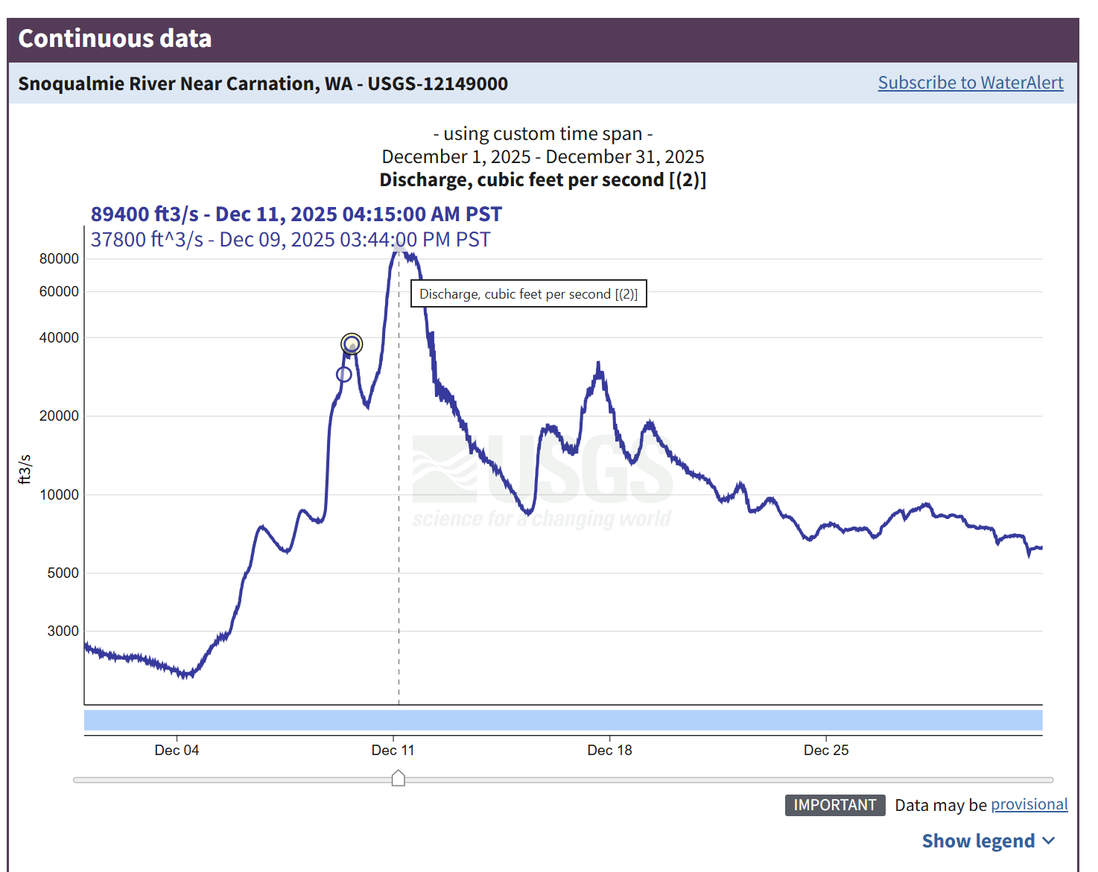 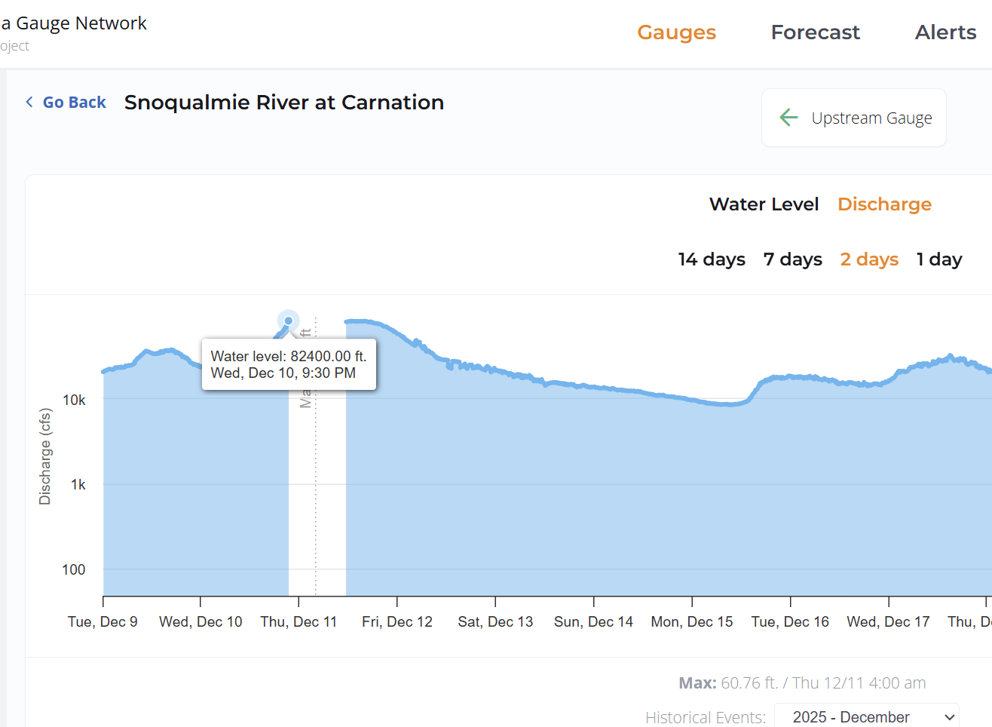
Sourced the final CFS from Snoqualmie River Near Carnation, WA - USGS Water Data for the Nation (left) as our Data was disrupted by a bug that didn’t capture the full data (right).

Carnation Gauge Prediction Timeline
Many many updated predictions came in between November 30th and December 11th. Here are some highlights:
Posted November 30th 2025 7:30AM: 18,002 cfs for December 9th
Posted December 6th 2025 6:30AM: 38,703 cfs for December 9th , 38,598 cfs for December 11th
Posted December 9th 2025: 71,735 cfs for December 11th 10am
The final maximum CFS recorded at Snoqualmie River Near Carnation USGS gauge was 89,400 cfs on December 11th 2025 at 4:15am.
Gauge Specific Details
SVPA-37 Snoqualmie Falls Golf Course
This gauge experienced no problems.

SVPA-36 Fall City – Neal Rd. SE
This gauge was inundated for part of the flood. It works well after the flood but will need to be raised higher.
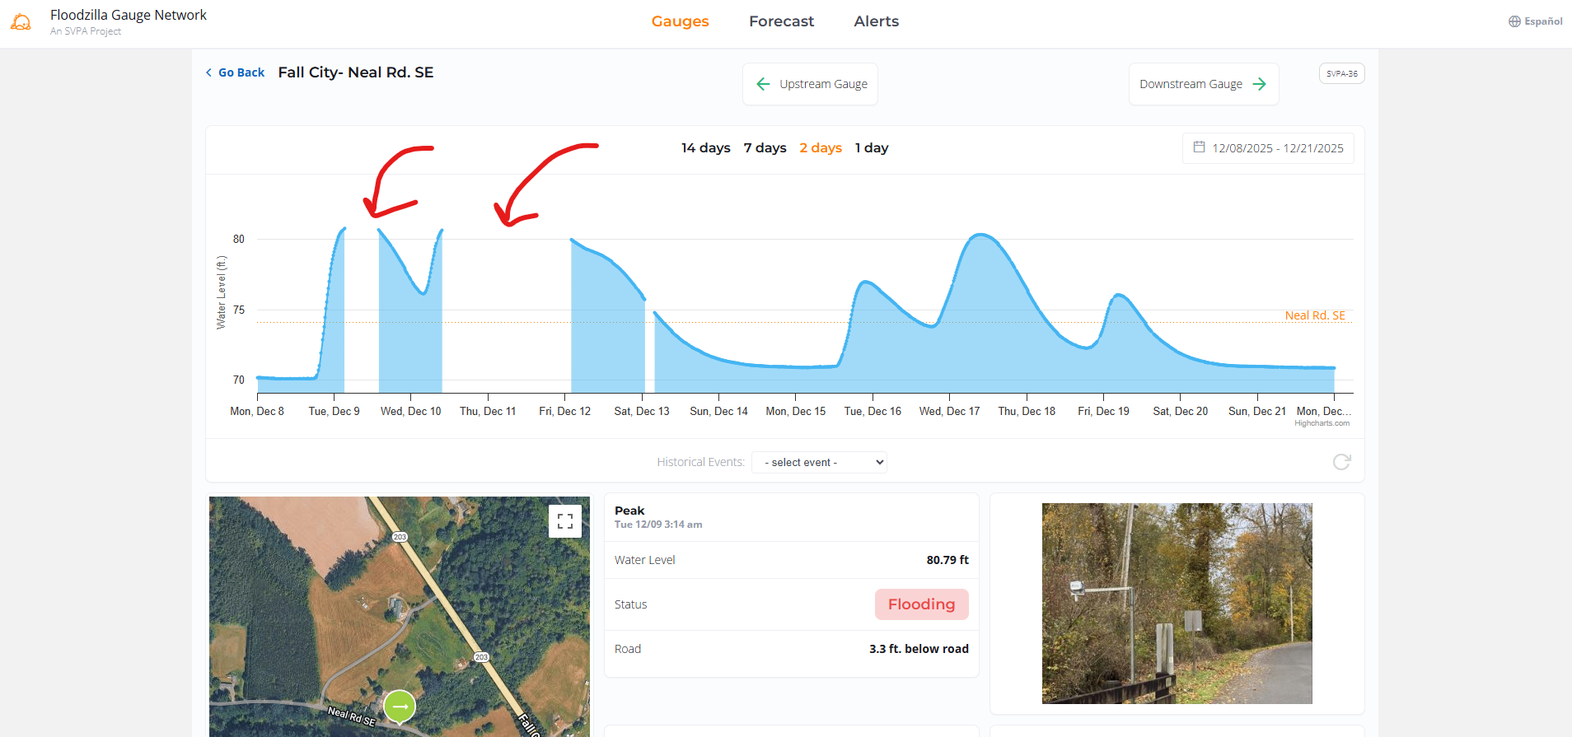

SVPA-34 The “T” at W Snoqualmie River Rd SE
This gauge filtered out the data for flooding because the water moved too swiftly. Eventually we corrected the data by unfiltering the bad readings.

SVPA-33 Snoqualmie River at SE 19th Way
At the site, both the posts for the platform were damaged/removed. The platform itself is still stable and attached. The benchmark is loose but still there.

SVPA-29 W Snoqualmie River Rd NE near Jubilee Farm
This gauge experienced no problems.

SVPA-26 W Snoqualmie River Rd NE at Blue Heron Golf Course
This sensor had bad readings throughout the flooding event and had to remain off. The sensor/device most likely needs to be replaced.

SVPA-25 Snoqualmie River at NE Tolt Hill Rd
Some major gaps in data transmission, which needs to be improved. We did not capture all the events when the water went over the road.

SVPA-19 Stuart Landing - South of Oxbow Farm

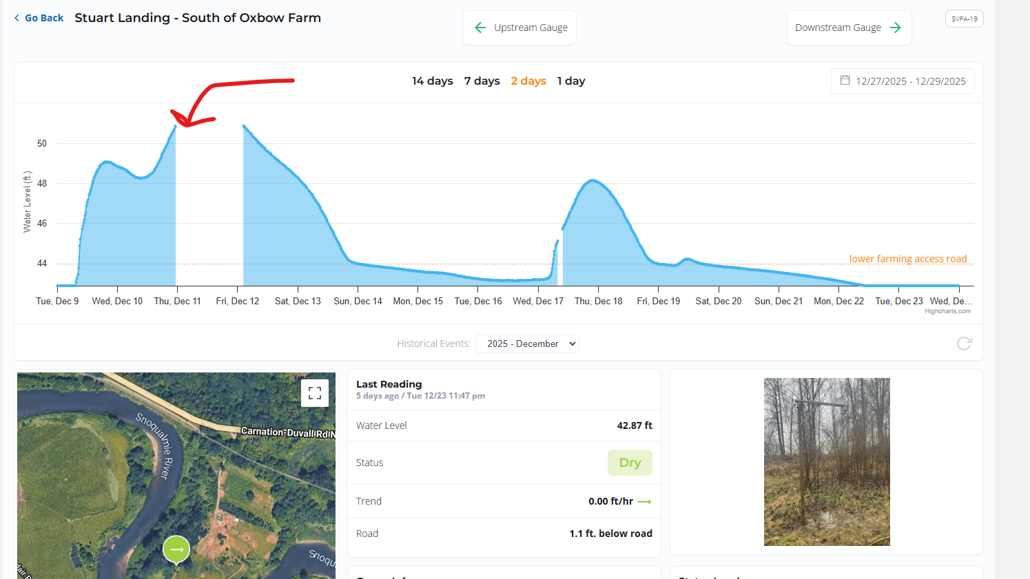 This sensor was most likely inundated and will need to be raised higher. The benchmark for where lower farming access road is is missing. It is a t-post and was most likely removed by a person.

SVPA-17 NE 100th St at Goose & Gander Farm
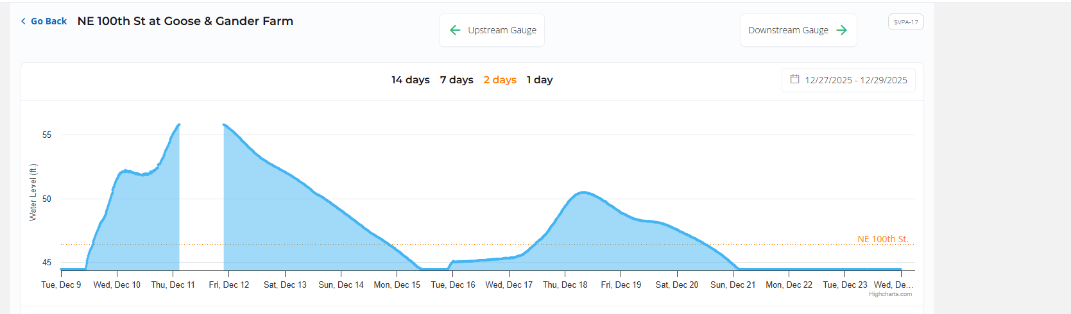
This gauge most likely was inundated based on the gap in data, and will need to be raised. More importantly, there is a request to have this gauge site better capture flooding for when water goes over NE 100th st. Water tends to spill out of the north side of the street, and then cross over to the field.
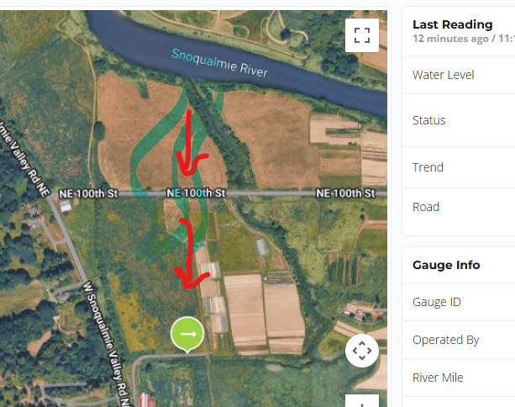

SVPA-15
This gauge experienced no problems.

SVPA-15B
There were some significant gaps in data that would have been nice to have during the flood. We missed some times where water went over the road and we don’t know why the data wasn’t transmitted. Most likely we need to improve the reception.
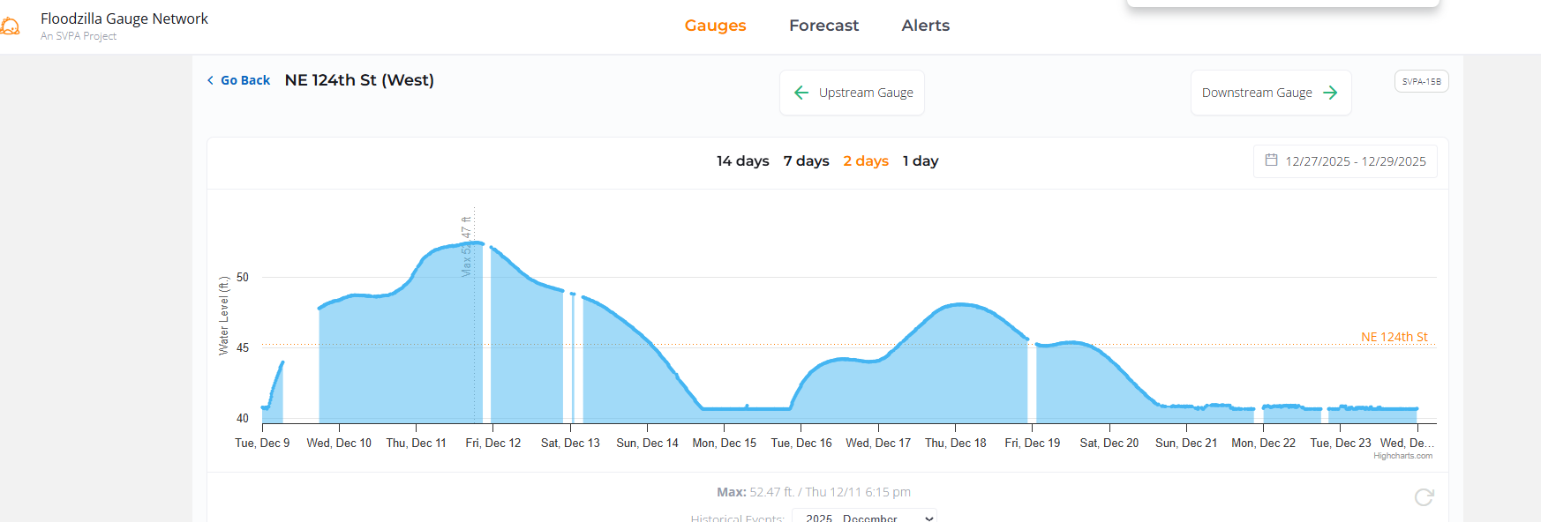

SVPA-12
The sensor may need to be raised higher based on the gaps in data.
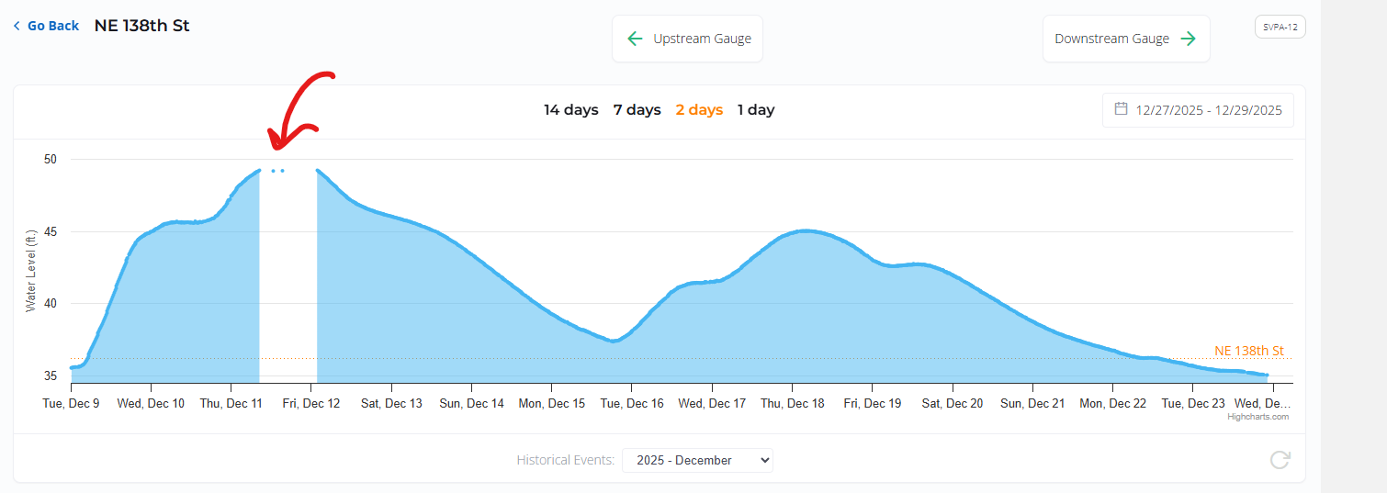

SVPA-6
Unknown but most likely inundated.

SVPA-6B
Unknown but most likely inundated.

USGS gauges:
USGS-SF17
USGS-MF11
USGS-NF10
USGS38

Forecast and Alerts and other website data issues:

-Dave Sanderman fixed a browser caching issue that caused the forecast lines not to show on the forecast page which was a javascript issue he was able to fix.
-There were issues with data coming in from USGS where they gave us a value of 0 for discharge that caused a dip in the graph. This was out of our control because they were providing us with a value of 0.
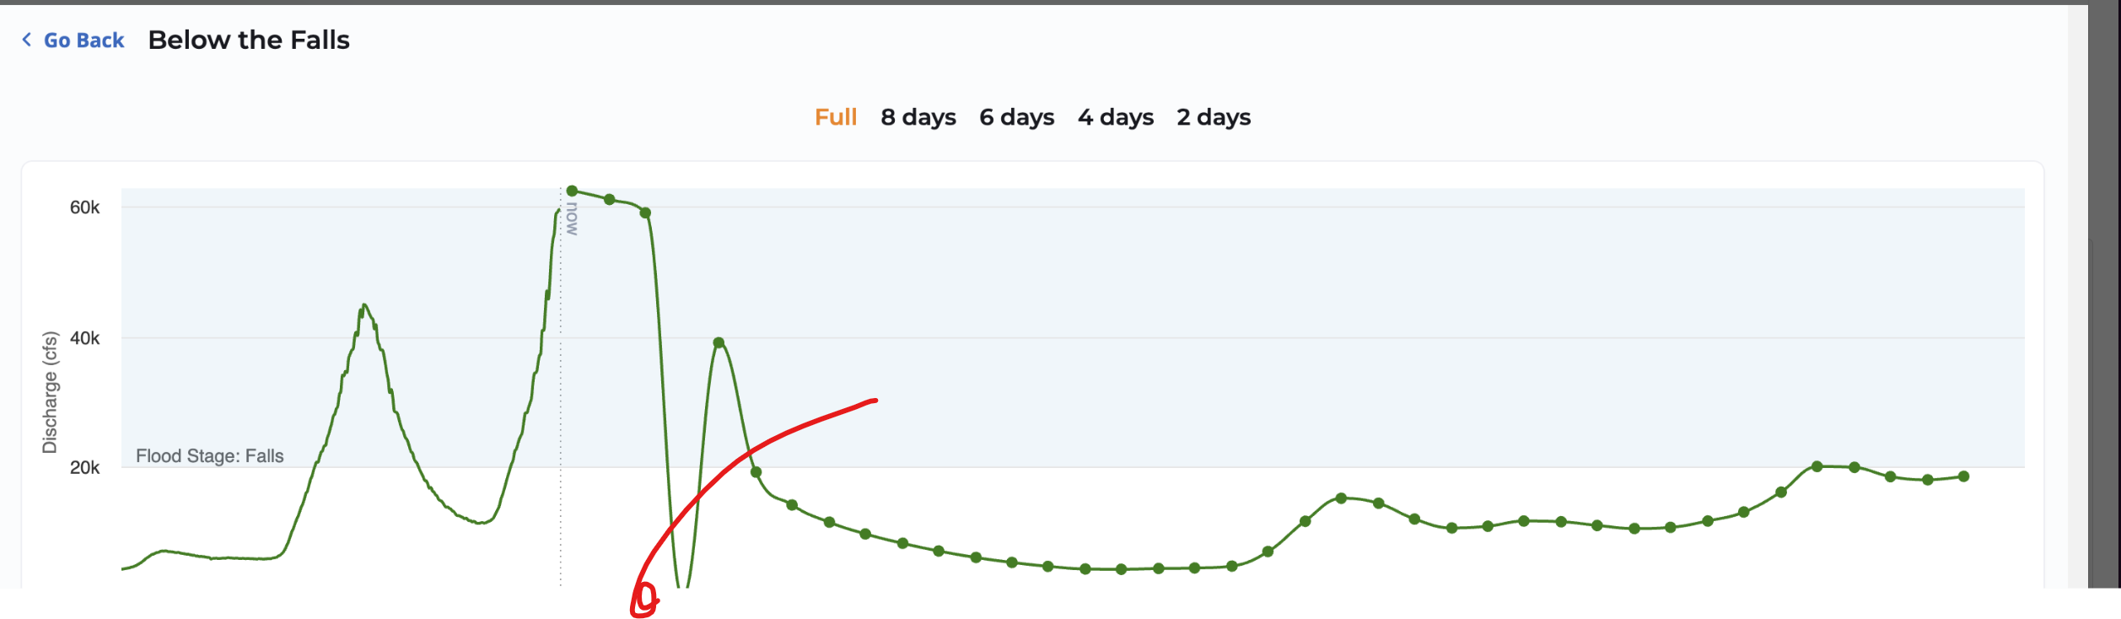

-We were not able to capture all of the discharge data for the Carnation Gauge due to a bug. We would have to manually go back in to enter the data.
We hit our $200 monthly recharge limit on Plivo, and Lauren raised the limit to $400 since we had so many texts going out. It cost us at least $515 to send out alerts in December, which was probably due to how many users we have signed up for alerts.
-Our Google Maps API for the website experienced some disruption due to over 10,000 views around December 11th. The problem was, the Dynamic Maps usage max we were set up for in December 2025 was 10k free requests per month. In our case in December, we actually had over 22k requests during December, which caused us to get charged. After looking at how many API requests we had during a major flood, Dave decided that December was a unique case and would probably not be the norm for most flooding events or normal usage during any given month for our Floodzilla website.
-We don’t have an official way for SVPA staff to fully unsubscribe someone from alerts. One of the emails we received included a request to be unsubscribed from the alerts. SVPA Staff needed the Web App Developer Dave to assist in a manual removal of the account.
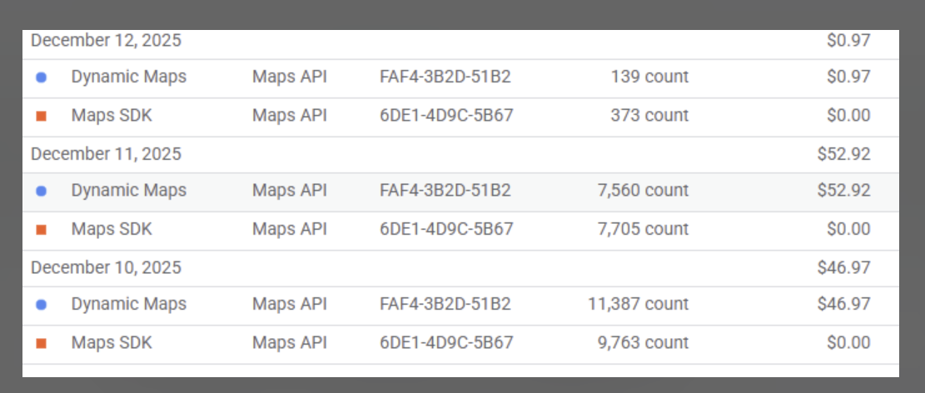
Example of the costs and counts for Dynamic Maps on December 10th through 12th.
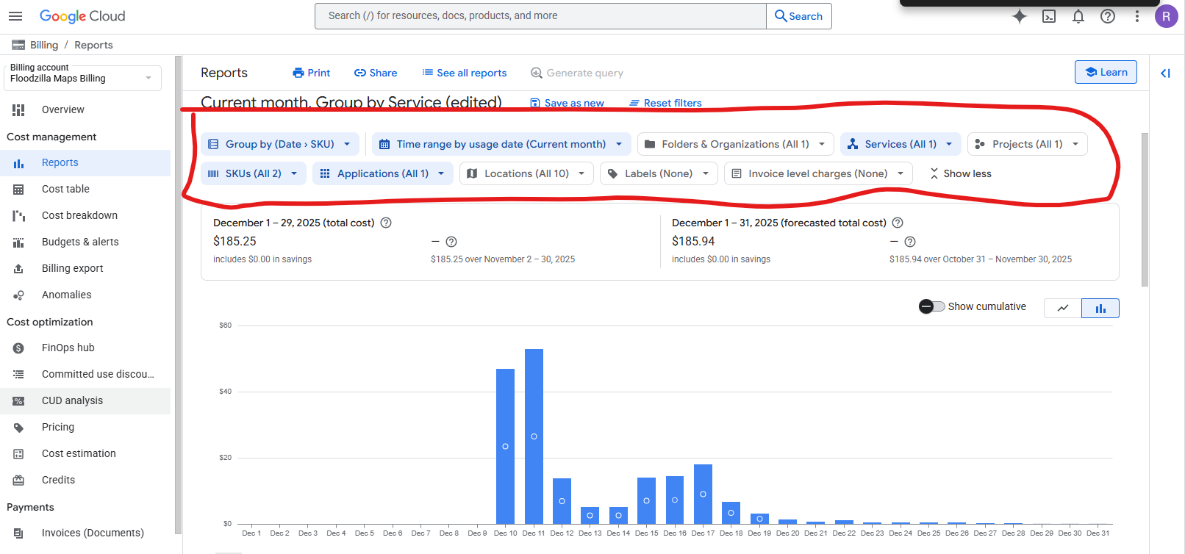
Graph for all of December costs for Google Maps API.

Gateways and other equipment:
We lost a gateway at Cherry Creek Pumphouse, as well as a backup battery set up. Newly deployed milesight gateway at the Snoqualmie Falls Golf Course worked well.
Other experiment going on at the time:
We were testing two gauges at the Tolt Hill Road location at the same time for part of the event.
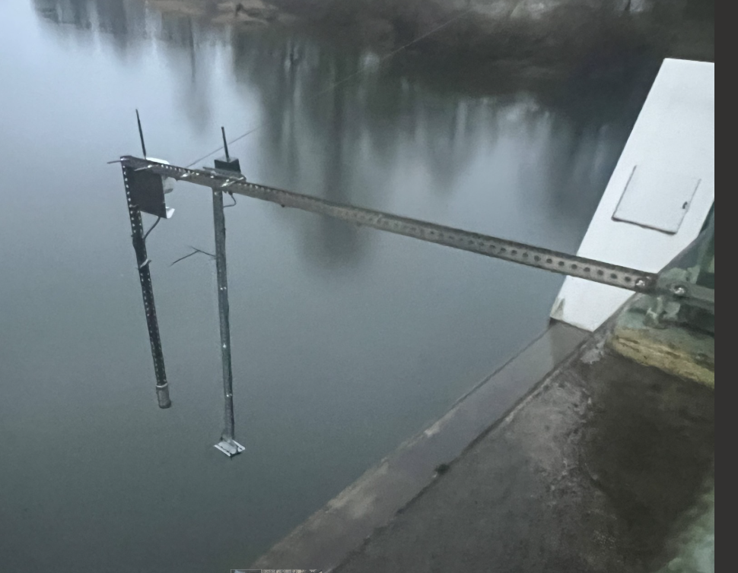
The hope was for the Dragino device to be a potential replacement for Senix Sensors. It did had reception to Geary’s house where we put a milesight gateway, but did not produce enough correct distance numbers for us to be confident in using it immediately. The Dragino device was only in the field from December 8th through 15th.

Actionable follow up Items
- Review Plivo subscription and decide on a subscription cost and cost expectations for major floods
- Review and change Google Cloud Console – See Google Cloud Console Guide document in Dropbox to address costs and expectations for major floods.
- Explore putting a chat for public to contact the SVPA staff via Discord– See Discord Floodzilla Forum Brainstorming document in Dropbox or implementing a chatbot service with set hours to contact SVPA staff.
- Manually enter in the data for the Carnation Gauge discharge that we missed.
Gauge Site-Specific actions:
- Find a way to not have The T gauge filter out flooding data.
- Replace the SVPA-29 gauge with one that works.
- Fix reception issues for SVPA-25 so that we capture more data points.
- For SVPA-19, write up a usage guide for the land manager so they know how to use and don’t remove benchmarks like a t-post.
- Review all benchmarks are still there, specifically the SVPA-33 and SVPA-19 ones.
- Raise the height on SVPA-36, SVPA-19, SVPA-17, SVPA-12, SVPA-6 and SVPA-6B. Note that gauge structures were built for 60 year floods, this was probably a 100 year flood.
- Relocate SVPA-17 to better capture flooding before it crosses 100th st to get to the gauge.
- Replace SVPA-6 and SVPA-6B

