Snoqualmie Valley Flood
October 20th - 23rd, 2019
Maleficent: Mistress of Evil

What went well:
- Validated that the website and Senix sensors are ready for primetime
- Website stayed up and had no major bugs
- Gathered lots of great data
- Good team communication
- Got data from all locations that were ready to go

Areas for improvement:
Senix communication / software issues:
- Sensors occasionally send duplicate issues (Geary to investigate the occurrence at Keller Dairy)
- Receiver goes offline after sending sensor updates (maybe coincidental, but happened twice for G&G cluster)
- Wild Canary sensor went offline for over an hour twice. Is this due to range limit or firmware bugs?
- Are the gaps at Wild Canary and Keller due to transmission range or something else?

Senix range issues
- Need to set sensor min/max in Floodzilla config.
- Need to investigate how to use Senix range settings.
- Not sure how we handle the accidental long reads when the water is close.
- Need to identify in device config which sensors are 15’ and which are 30’

Sensor deployment
- Make sure sensor is configured in liquidlevels correctly before taking into field (offsets, min, max,etc.) Do a test run to make sure data is showing in liquidlevels.
- Agree on naming convention for sensors in liquidlevels. When sensors are hot swapped during a flood it gets confusing if the names get duplicated or change.
- A number of our sensors were close to getting wet. What should our strategy be here? The 2009 flood was 4.5 ft higher in many places but is close to 100yr range. Do all sensors need to be above the 100yr level or are we OK if we lose some sensors in a 10yr (or some other level) event? This flood was probably in the 5yr event range.
- Need to consider cantilevering some sensors out further from the post. It appears that the post at the T picked up debris from the water than then was picked up by the sensor as the water receded.

Locations
- Our 124th location did not measure the rising event but appears to be working for the falling event:
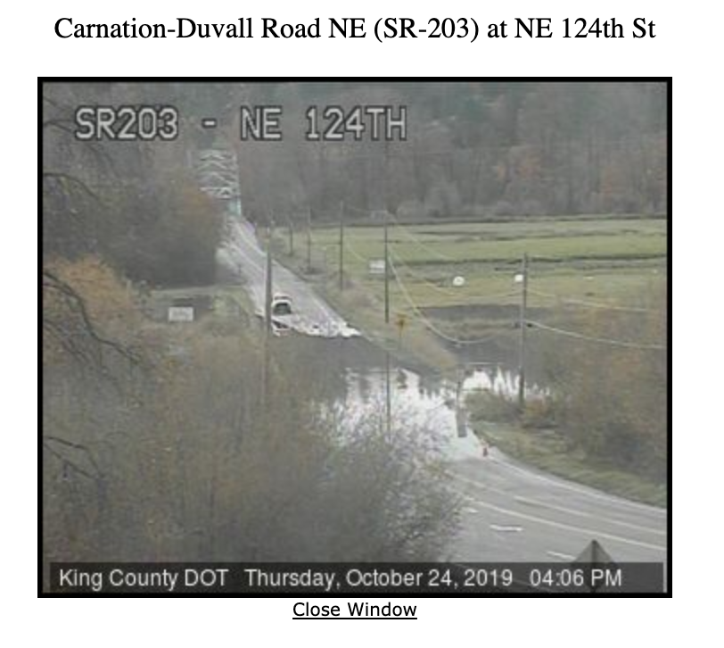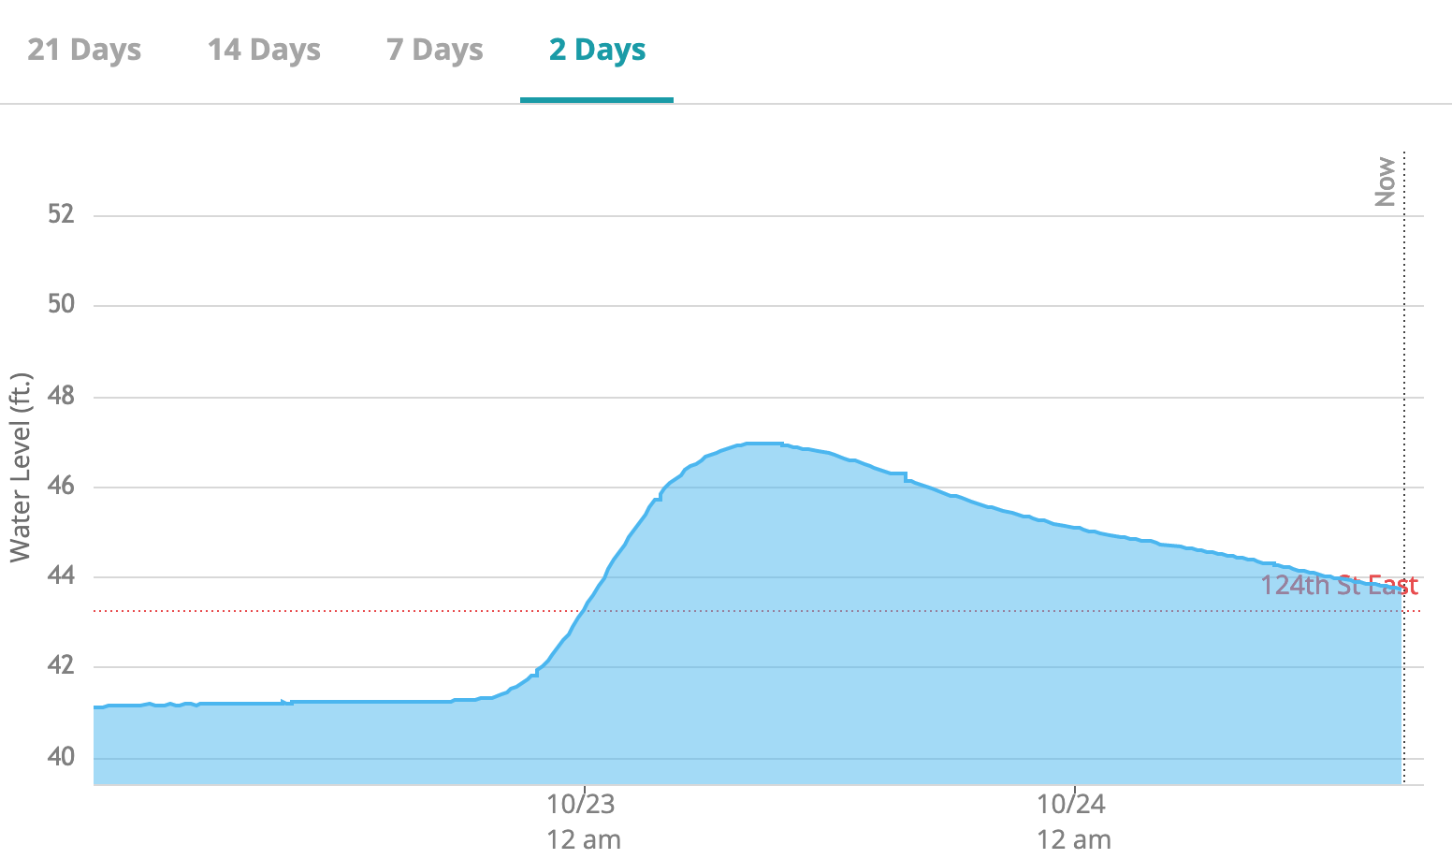
- Possible issue: I drove home last night past Blue Heron through a few inches of water flowing over the road. The water was flowing from west to east (toward the sensor). The water level at the sensor was 4-6” below the road even though there was still 3” flowing over the road. The result is it looks like the water is below the road surface on our site but it is still over the road.

Admin/backend software
- Recent Reports is tied to a device which makes it hard to find history when devices change at a location. Is it possible to provide the same tool but tied to locations instead?
- Task runner doesn’t restart on failure

Public web site
- Mobile view needs some UX work.
  - Location names cut off
  - Details charts have too much side margin
  - Touching chart hard to see where on timeline the pop up is
  - Need map
- Need a better way to navigate between sensors. Going back to the list takes you to the top of the list again.
- Data gets stale in the list view. Going back to list from detail view does not refresh list even if it’s been hours since the list was loaded. List should reload data if it’s been longer than 1m.
- Would be nice if data loaded in the background. Full screen modal loading wheel makes the site feel slow.
- Adding an autore-fresh mode would be nice. Maybe have an inactivity timeout if we are worried about zombie browser DOS.
- Need to show difference between current height and road.
- Bug: “Two day” range varies from 2 to 3 days depending on time of day
- Need to zoom in beyond 2 days
- Consider defaulting to 2 days range instead of 21
- Times should be in location local time not browser time
- Consider changing “Starting to Flood” to “Near Flooding” or similar
- Consider extending the time period of inactivity before marking a location offline
- We made a decision last spring on a name (I think something like “Floodzilla Gage Network”). The plan was to push the branding more towards Floodzilla including the orange logo. Do we still believe that is the right approach? If so we should spec out what changes we want to make.

Gage Data
- We need a process to clean data after (and maybe during) a flood event.
- We need a process to record the cleaned flood data range for each location.
- Dave and Geary to review how the gage data is stored to make sure we can maintain historical accuracy
- How do we communicate the difference between navd 88 that we use and ngvd 29 that the carnation station uses?

Notes
- Need monitoring during floods. How do we assign and communicate?

Tasks:
- Build a flood on-call system
- Need pre/post flood sensor prep protocol
  - Check for debris. Check sensor alignment.
- Geary to tell Dave how to mark the flood for the locations
- Create recent reads by Location (add pagination, date ranges, export)

--

