Using Senix Sensors with Floodzilla
In order to use Senix AirWire sensors with the Floodzilla system, two steps must be taken: the sensors must be registered using the Floodzilla admin pages, and the AirWire receivers must be configured to send data to Floodzilla.

Registering Senix sensor/transmitters with Floodzilla
Registering the Senix sensor/transmitters with the Floodzilla system happens entirely within the Sensor admin pages. This step should be done before deploying the sensors. All the necessary information is on the sensor serial-number plate:
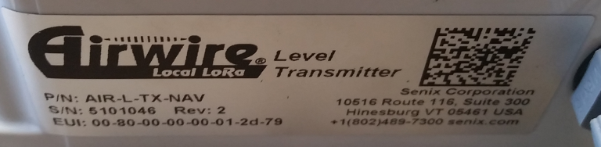
In particular, you will need the serial number (“S/N”) and the External Unique Identifier (“EUI”).

To register a sensor, go to the Devices admin page and click “New Device”. You will come to a page that looks like this:

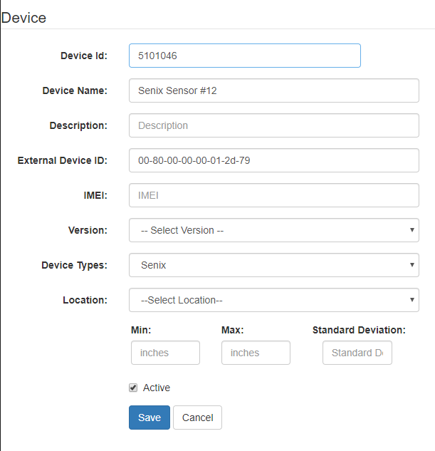
The important fields:
- Device Id: Enter the serial number for the sensor.
- Device Name: Choose a name to refer to this sensor; this can be changed later.
- External Device ID: Enter the EUI from the labe. Use all lowercase for letters.
- Device Types: Select “Senix”
Version and IMEI should be left empty. Location can be specified once the sensor is deployed.

Configuring AirWire receivers
The AirWire receivers should be configured to send data to the Floodzilla servers. Once the IP address for the receiver has been determined (via DHCP or direct configuration), use a web browser to go to:
http://<IP ADDRESS>:8080/config
You will see a configuration page; at the bottom will be the HTTP Post section:
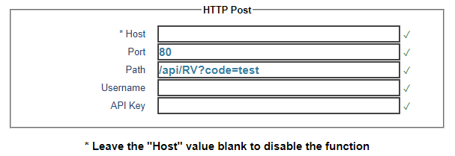
The important fields:
- Host: senixlistener.azurewebsites.net
- Port: 80
- Path: /api/RV?code=test
As the text at the bottom of the dialog says, if at any point we need to disable this receiver from sending data to Floodzilla, just remove the “Host” entry.

