Post-Flood Evaluation:

June 9th to 13th 2022

By Regina Fletcher

Introduction

The timeframe of June 9th through June 13th was a unique rainfall event in Western Washington. The city of North Bend, located near the primary headwaters we monitor, received 1.33” of rain within 24 hours, and added up to 2.2” total of rainfall by June 13th (North Bend Weather, n.d.). Average rainfall in North Bend typically receives an average of 1.54" in the month of June (Weather Atlas, n.d.). This rainfall accumulated across the 30-mile stretch of Floodzilla’s gage monitoring system. SVPA’s flood technicians evaluated and deployed flood gages to sites. A camera trap was also deployed at an easily accessible site which overlooked a transportation route vulnerable to significant flooding. We received inquiries from community members about redeploying gages taken down for summer maintenance, and there was media coverage on the flooding event. The following is a report on Floodzilla’s monitoring techniques this time and the data’s relation to the community’s resiliency.

Gage Details
The following includes information primarily about the functionality of SVPA gages, with a final mention about all data incorporated into the floodzilla website including USGS gages.

Timing
SVPA gages were redeployed June 7th through June 9th in anticipation for a flooding forecast on June 10th. Initially the forecast fluctuated in both height of water and timing, and was finally forecast to just below offical flood stage (Appendix A). Field work was completed at 9pm on June 9th, and final gages with correctly displaying data were turned online for public display at 5:29am, June 10th. The first flooding detected by an SVPA maintained gage at Neal Road at 5:29am June 10th.

The decision to redeploy flood gages with a safe buffer time of approximately eight hours proved useful for being able to collect and display important flood data for the public, especially the upstream site SVPA-12 at Neal Road. Improvement for next time would be to have the field technician turn gages online within a few hours of deployment, after evaluating data to make sure it is reading correctly.

Coverage

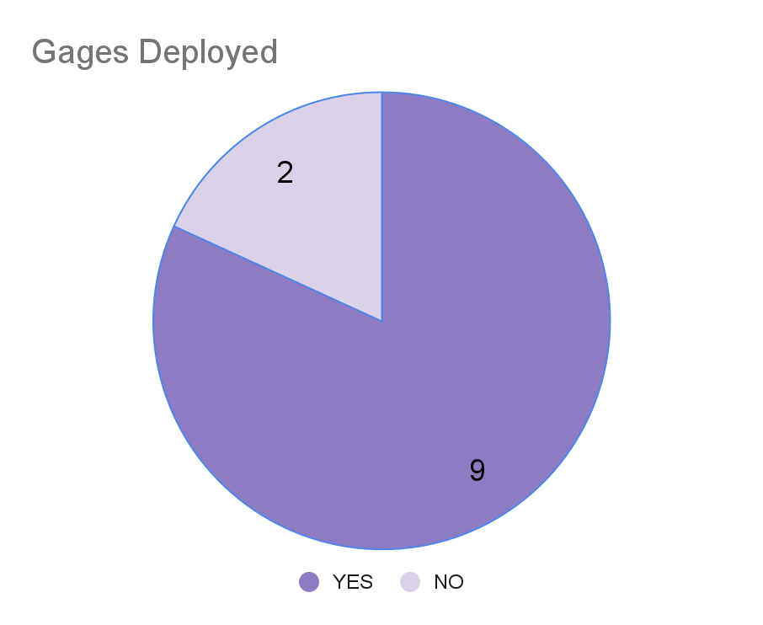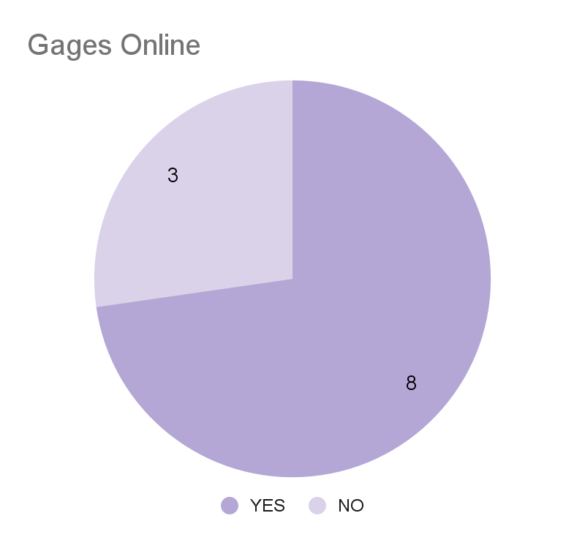
Figure 1. Gages deployed June 9th, and gages online on June 10th.

We had nine out of eleven gages deployed in the field. Eight out of eleven were online beginning June 10th at 5:30am. Three were not online, with one due to a display of incorrect data seen on the backend of floodzilla, two were not deployed due to time constraints.

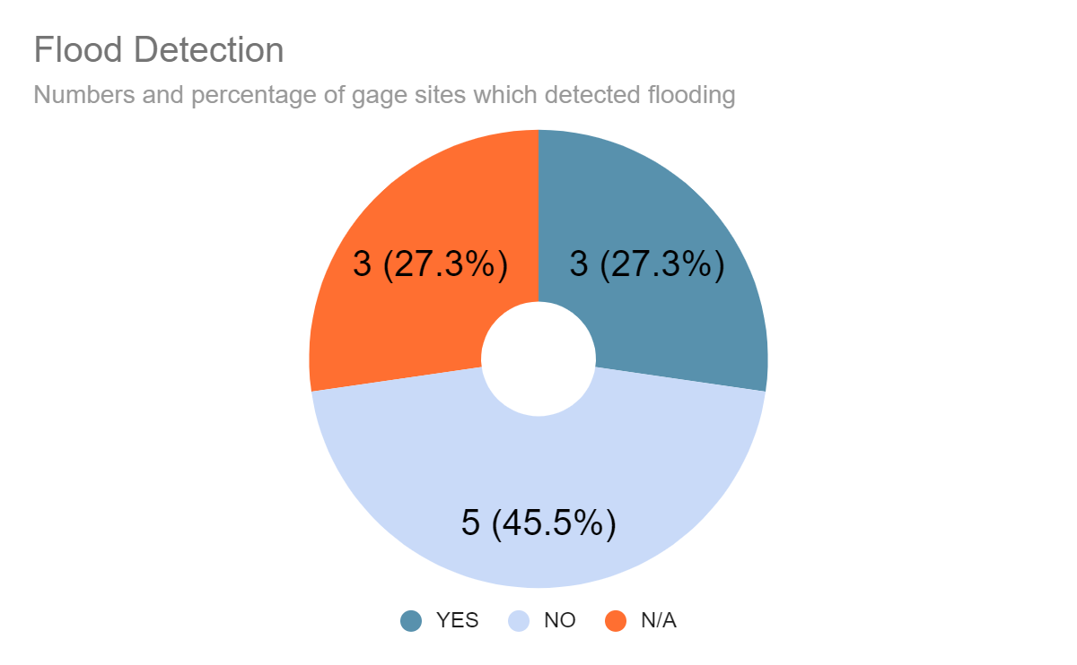
Figure 2. Values and percentages of SVPA gages sites which detected flooding.
The weather events brought site specific flooding to Snoqualmie Valley. Out of the eleven established monitoring sites, three reported flooding and five reported no flooding. Three were without information due to being offline. The detected flood crest heights ranged from 75.47 feet at an upstream site to 39.59 feet downstream (Appendix C).
Overall, coverage on the Floodzilla website also includes seven USGS maintained gages, which displayed a total of 15 gages for the public during the event. Through the ability to accurately and cohesively display this data for the public in one place, we are able to essentially double the amount of data available for decision making and analysis during unprecedented weather events.

Seasonal obstacles
Gage sites were cleared of reed canary grass, blackberry, and buttercup which had all grown to their full height. Extra care was taken to trim buttercup down to visible mud level to make sure the site correctly detected the site as “dry”.

Individual Device Info
Batteries remained charged throughout the event, and reception from devices was good with no major gaps in transmission of data. In the future it could be useful to quantify this in further detail for reports.

Camera Trap Experiment
During this unique flooding event we experimented with a camera trap as a potential future option for flood monitoring. Some of the potential future uses for a camera trap could include a more comprehensive understanding of horizontal water movement across a road through visual data, and also for calibrating flood sensors or remotely interpreting data issues.

Methods
We placed a “XR6 Ultrafire Covert Camera” along the north side of NE 124th st in Duvall, WA at lat/long: 47.70910520844634, -121.98623272514793 (Appendix D). This site was chosen out of accessibility and local knowledge of where NE 124th typically begins flooding. Camera was approximately five feet off the ground and securely tied to a telephone pole facing southwest. A python lock was used for security measures. We applied an approximate 5% tilt downward with small sticks wedged between camera and telephone pole. Both the road, SVPA-15, and its drainage ditch were visible in the camera lens (Appendix E). Both sides of the roads were intended to be visual indicators to confirm flooding across the road. The camera was deployed from June 9th 2022 1:45pm to June 13th 2022 at 10:45am. Fresh lithium batteries were used, and the camera was set to take one photo and one video every 15 minutes beginning at 1:45pm. The memory card used was a Kingston 32GB.

Results and Discussion
Due to the nature of the flooding event, it appears there was no flooding of NE 124th st. Both gages SVPA-15 and 15B at either end and side of NE 124th showed no sign of the water reaching the road, and a manual scan through the photos captured showed no water coverage on the road during the timeframe. Approximately 18% of the memory card was full and battery level was displayed as fully charged.

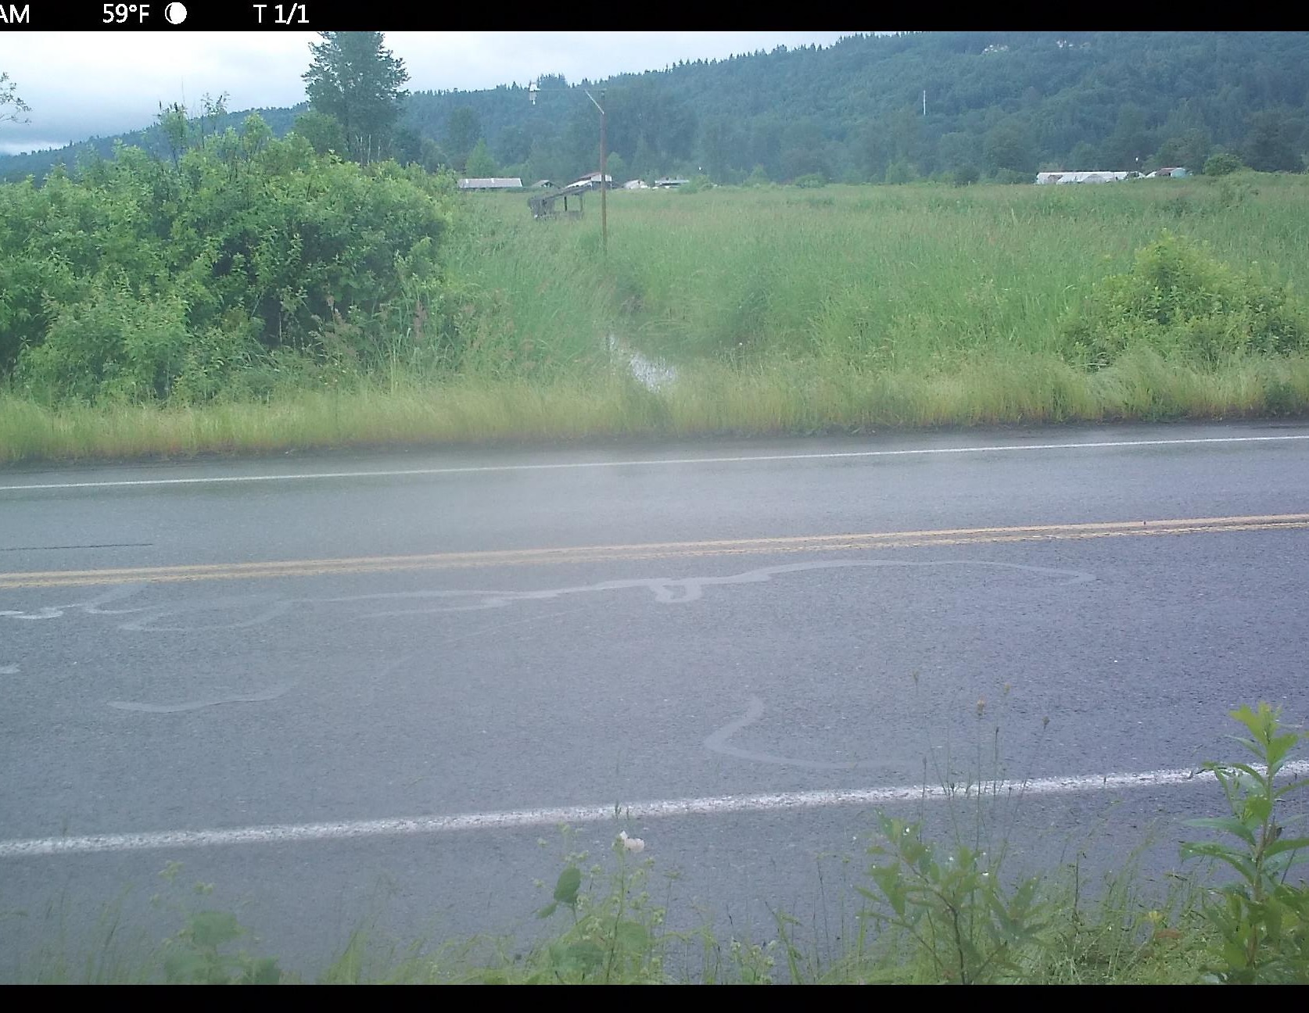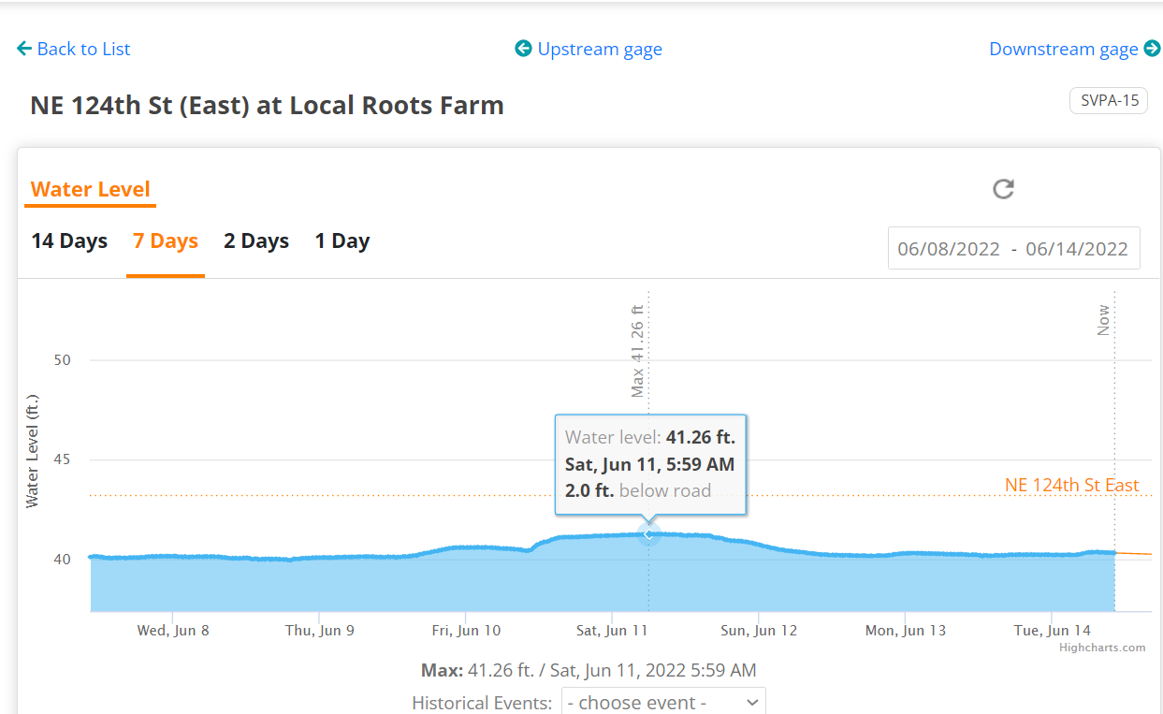
Figure 3. A cropped camera trap photo during highest recorded water level.
Figure 4. SVPA-15 gage data highlighting the closest matching timestamp.
Based on the collection of photos, in the case we did use these to monitor larger flooding events, there are several ways to improve this supplementary monitoring method. First would be to better define the flooding visual indicator with a white object in view with measurement markings and within a good viewing range for both day and night photos. The range and detail of the camera trap’s photos appears to decrease during nightfall, which makes the dark gray edge of the road difficult to evaluate for flooding. Figure 5 shows an interpretation of the range of visibility of the road during the two categories the day. Second improvement would be to find a way to navigate long periods of time without a site visit. Based on this current method, a singular camera trap would need to be visited every twenty days, or earlier to prevent any gaps in data due to the memory card filling up. This issue could either be accomplished through a larger memory card, or investing in a different type of camera trap which includes cellular data and remote access. A final note for improvement would be how the camera is placed. These devices are typically built for capturing wildlife moving horizontally through the camera view. With a general goal of monitoring vertical movement of water levels, the camera trap could be deployed at a 90 degree angle.
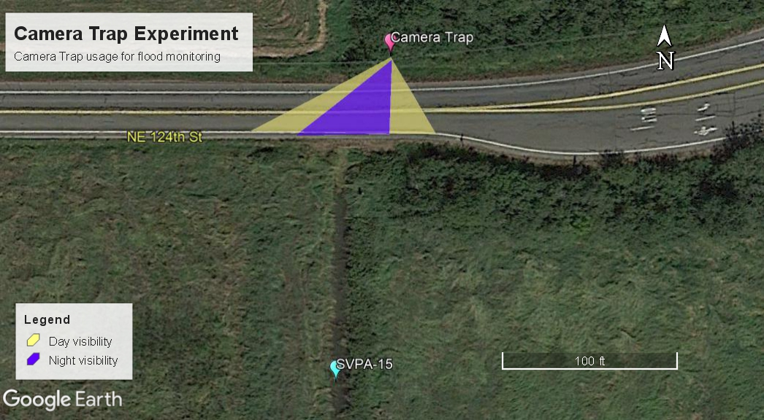

Figure 5. Camera trap’s visibility of road during two different categories of the day.

Community

Requests
We had requests during the week of June 6th through June 10th for redeployment of SVPA- 12 at Wild Canary farms, and SVPA-34 at the “T”. Unfortunately the readings on the “T” were not relaying correct data, so it was kept offline. The road at at Wild Canary farms was submerged in 3.5 feet of water during the highest point of the flooding, and remained covered with water for over three and half days.

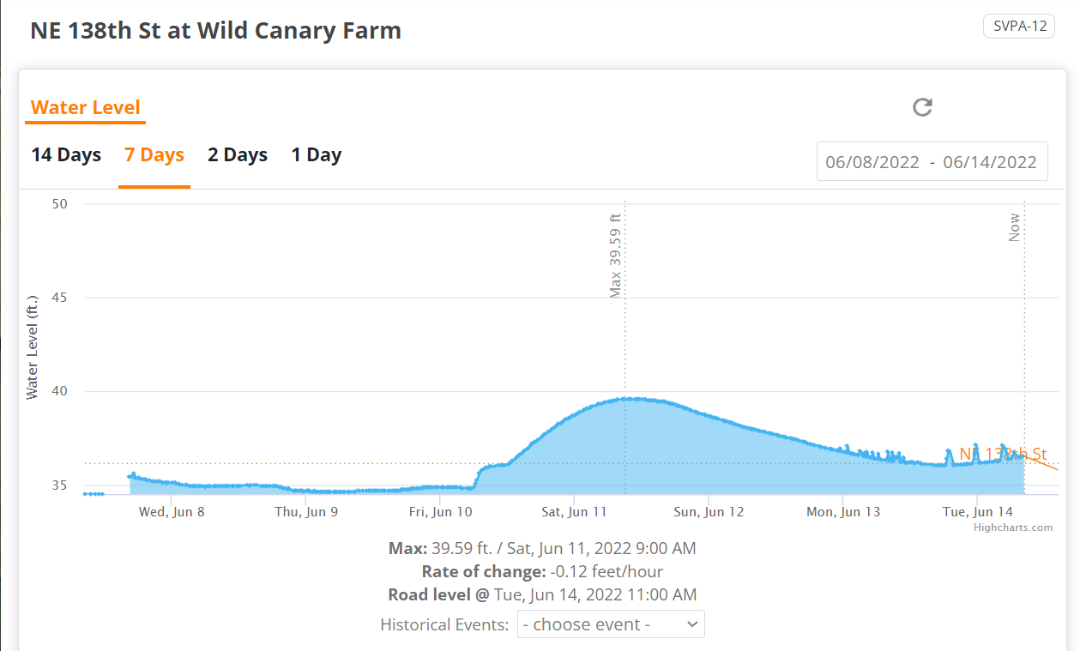

Media Coverage
SVPA’s executive director Lauren Silver was able to connect with King5 news and David Haakenson Jubilee farm on June 10th to relay info to the public on the effects of the heavy rainfall this June on farmers and their crops. Some details include how the flooding affects soil structure, and how crops cannot be sold once floodwaters have touched them (citation). These relate to the importance of flood gage data to be available for farmers to predict when to harvest their crops and salvage income instead of a total loss. In the future, short term tasks of redeployment and upkeep of gages through June could help farmers navigate swift changes in weather.
SnoValley Tilth’s executive director Dave Glenn was interviewed by the Snoqualmie Valley Reporter. He mentioned the unusual June flood has farmers in the area concerned. Usually farmers in the Snoqualmie Valley wait until the typical flooding risk has passed before planting their crops, typically in late March and April (citation). Long term goals of maintaining data of flooding events in full detail over the years as far as June could help stakeholders better convey solutions and understanding of what a new typical flooding risk timeline could be.

References
Retrieved from: https://www.valleyrecord.com/news/snoqualmie-valley-farmers-are-concerned-about-unusual-june-floods/
Retrieved from: https://www.king5.com/article/life/food/washington-farmers-face-challenges-rainfall/281-4eae9a63-256d-4050-a147-e94f2ca97437

Retrieved from: https://www.valleyrecord.com/news/snoqualmie-valley-farmers-are-concerned-about-unusual-june-floods/

Heavy rain season leaves Washington farmers with significant challenges. King 5. Retrieved from:
https://www.king5.com/article/life/food/washington-farmers-face-challenges-rainfall/281-4eae9a63-256d-4050-a147-e94f2ca97437

North Bend Weather. (n.d.). Retrieved from: https://www.northbendweather.com/wxraindetail.php?r=wxraindetail.php

Weather Atlas. (n.d.). Retrieved from: https://www.weather-us.com/en/washington-usa/north-bend-climate#rainfall

Appendix
Appendix A
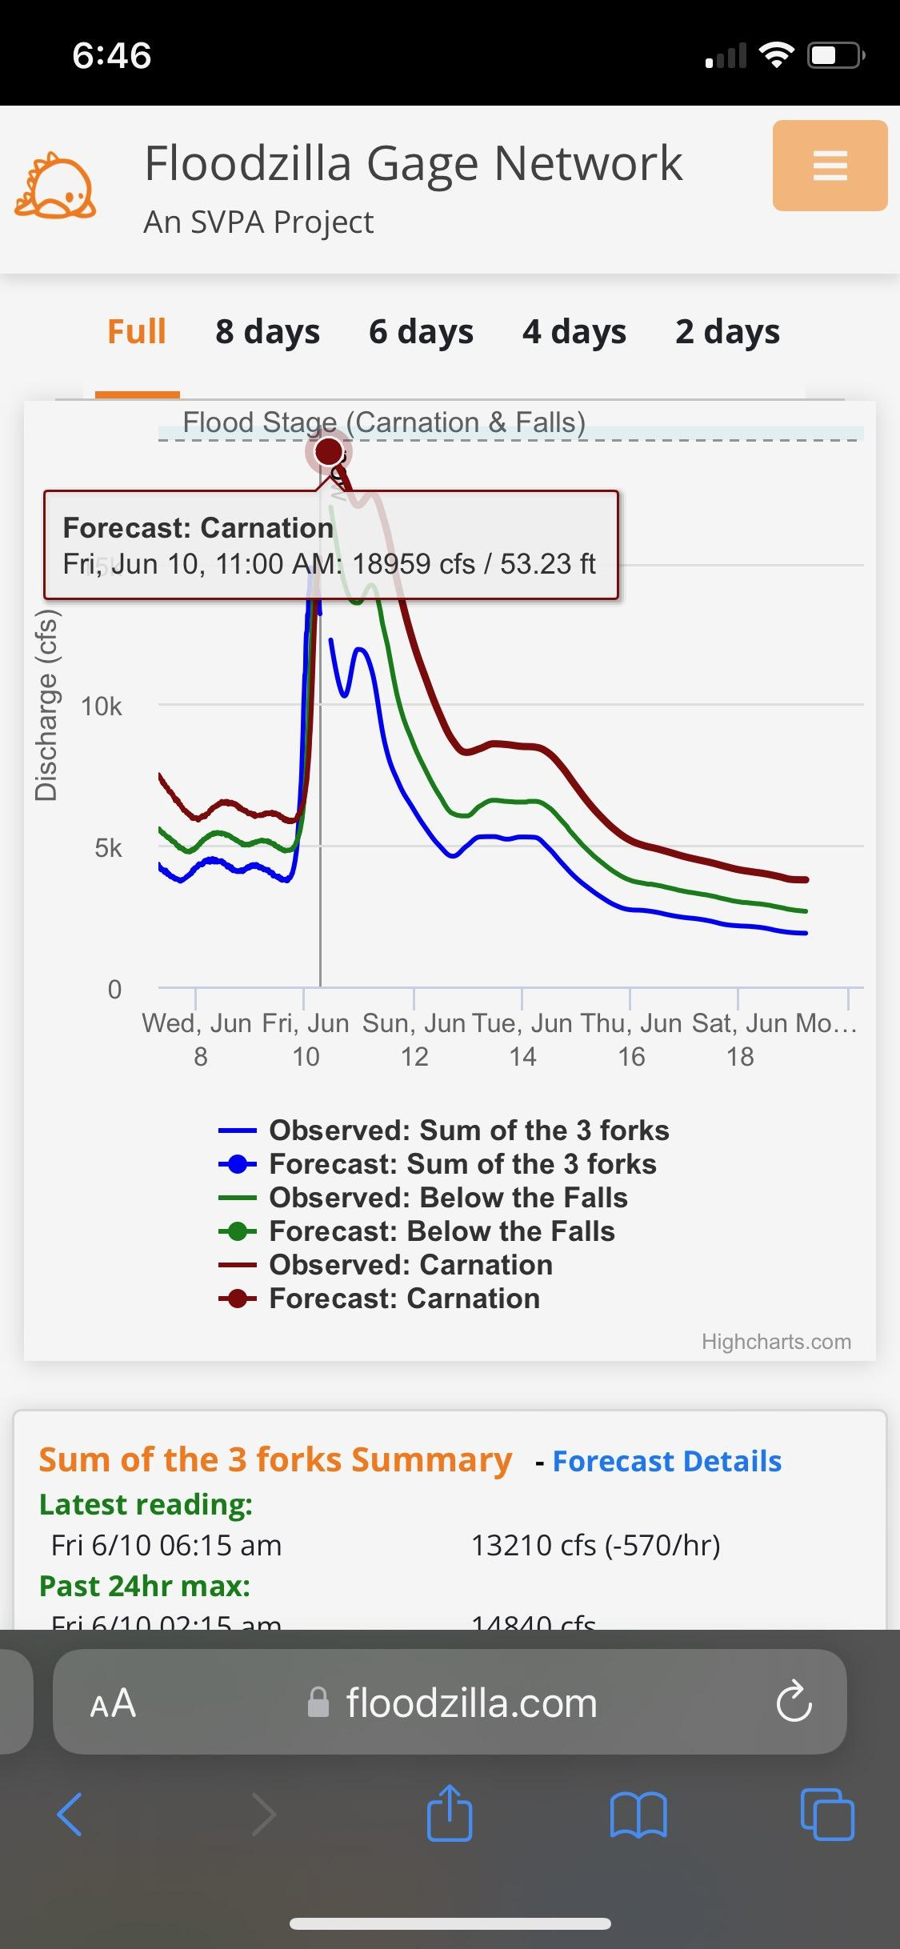
Appendix B
Gage Id | Deployed | Online | Notes
SVPA-12 Wild Canary Farm | YES | YES
SVPA-15B 124th st West | YES | YES
SVPA-15 124th st (local roots) | YES | YES
SVPA-17 Goose and Gander | YES | YES
SVPA-25 Tolt Hill Rd | YES | YES
SVPA-26 Blue Heron Golf Course | YES | YES
SVPA-29 Jubilee Farm | NO | NO
SVPA-33 Keller Dairy | YES | YES
SVPA-34 The "T" | YES | NO
SVPA-36 Neal Road | YES | YES
SVPA-37 Snoqualmie Falls Golf Course | NO | NO

Appendix C
Gage Id | Flooding Detected | Crest height | Notes
SVPA-12 Wild Canary Farm | YES | 39.59
SVPA-15B 124th st West | NO | 41.86
SVPA-15 124th st (local roots) | NO | 41.26
SVPA-17 Goose and Gander | NO | N/A
SVPA-25 Tolt Hill Rd | NO | 66.74
SVPA-26 Blue Heron Golf Course | YES | 67.24
SVPA-29 Jubilee Farm | N/A | N/A
SVPA-33 Keller Dairy | NO | 79.19
SVPA-34 The "T" | N/A | N/A
SVPA-36 Neal Road | YES | 75.47
SVPA-37 Snoqualmie Falls Golf Course | N/A | N/A

Appendix D
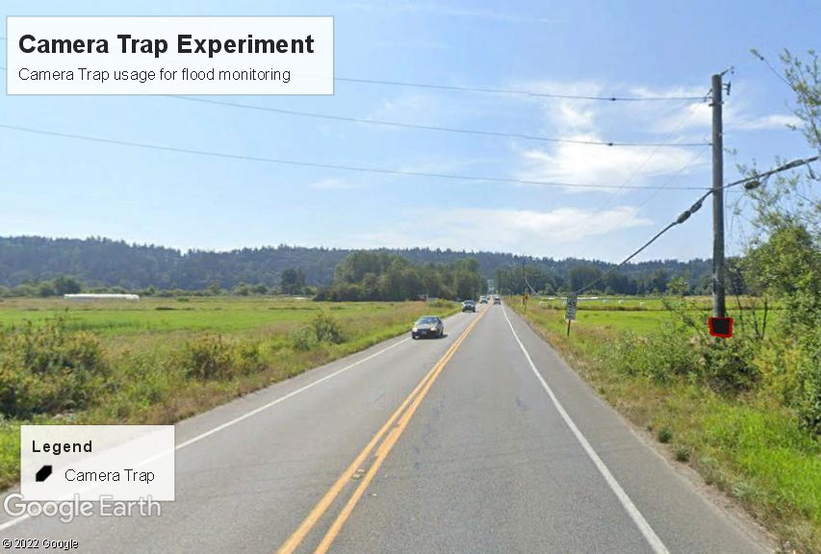
Appendix E
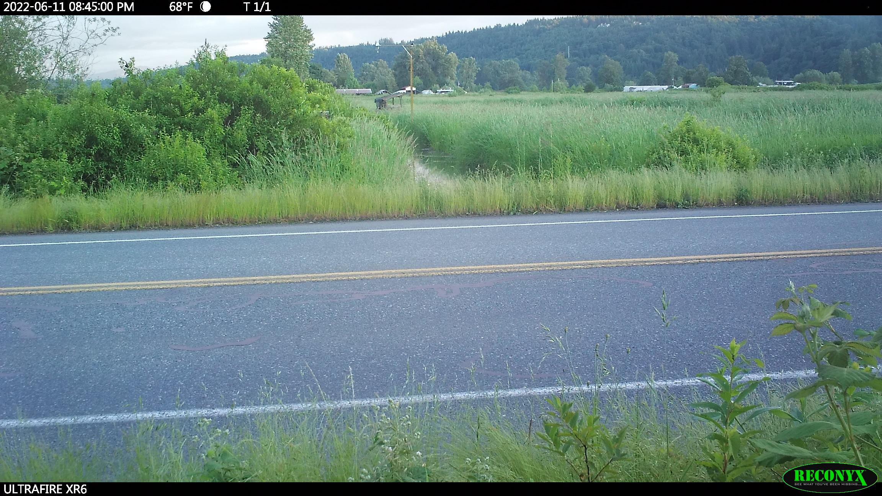

Appendix
