Post-Flood Eval March 2026
By Regina Fletcher

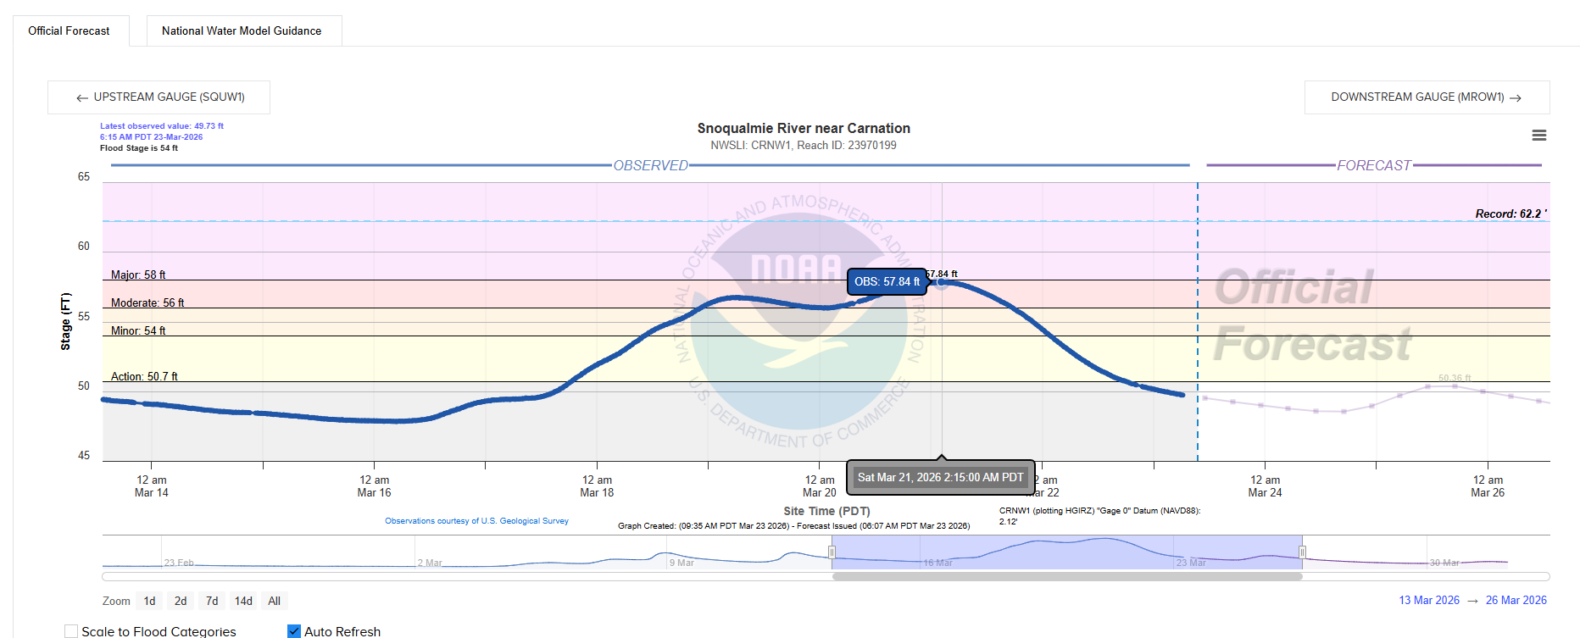
Screenshot from water.noaa.gov/gauges/CRNW1website March 23rd, 2026.
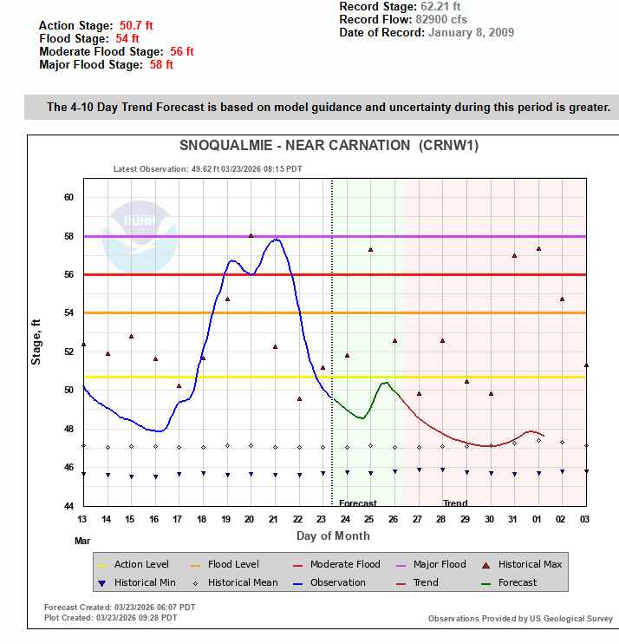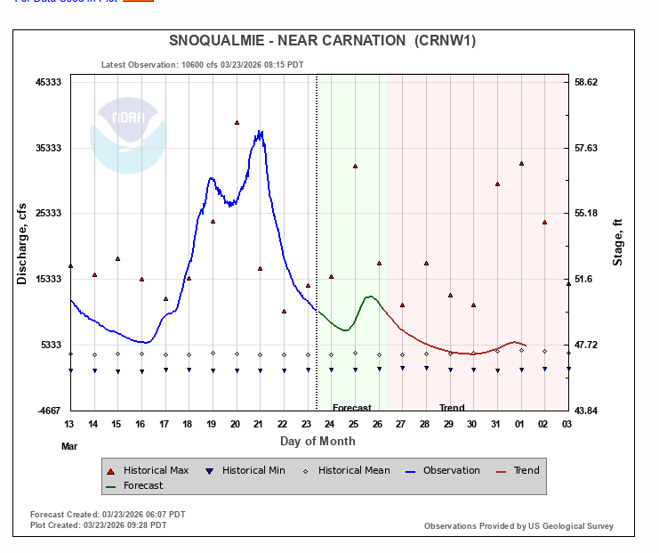
Screenshot from NWRFC website March 23rd, 2026.

This flooding lasted from March 17th through March 24th , which was about eight days of inundated roads in the valley.
What went well:
SVPA coordinated a dedicated 16 hour shift for the flooding event with four staff members, and communicated fixable issues throughout flooding event
Web/app developer Dave Sanderman was able to fix bugs during the flooding event as they appeared on our website and phone app versions
Newly purchased Milesight gauges read distances well, and the thingsstack and milesight gateways performed well
We were not charged for API requests via Google
No poweroutages (even though we were ready at some gateway sites for that)
What didn’t go well:
Several gauges experienced reception issues that cause major gaps in data transmission
There is a development in the SMS text message world/technology where our alerts are categorized as spam by different carriers causing certain cell phone carriers not to receive our texts
The original outdoor gateway on top of Goose and Gander Barn stopped working the month before, and we were using a different receiver at the second story of the barn that may have caused lower reception at that location.
Google Maps API Usage/Cost
Although we ad API requests in general go up for our Floodzilla/google maps platform, we were not charged like we were in December. And we have a $100 budget set for in case we are ever charged.

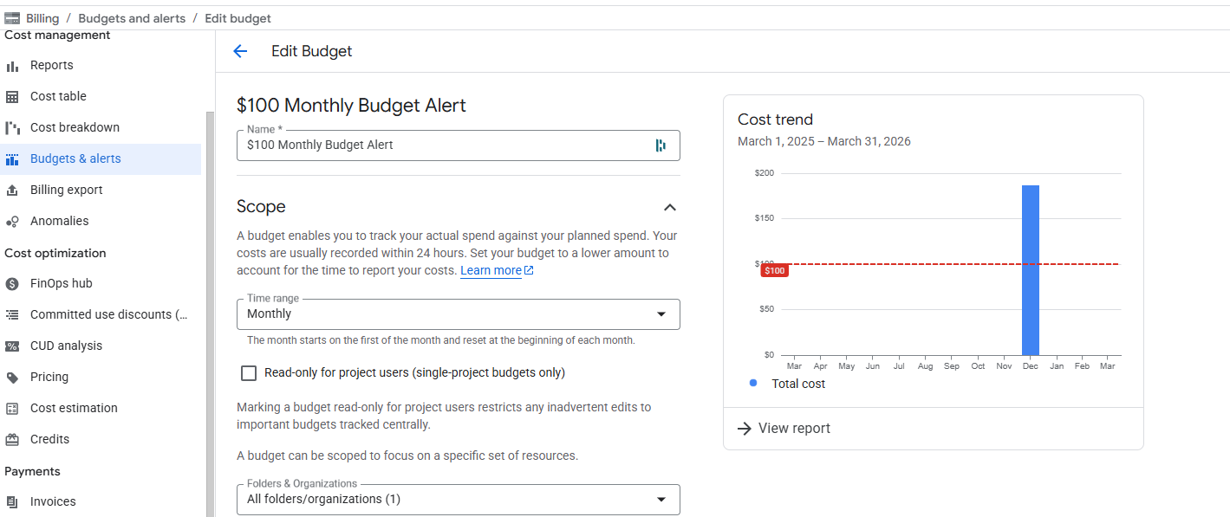
Plivo SMS Text Messages
Floodzilla Gauge Between December 24th 2025 and March 23rd 2026 we spent $386 sending out text messages to about 1,170 users. Recall that the flooding in December 2025 cost us $515 and we had around 1,148 users signed up. However for this flood we had two fewer gauges online so that could have reduced the number of people signed up for alerts.
 | Plivo Costs | Number of Users
December 2025 Flooding Event | $515 | 1148
March 2026 Flooding Event | $369.80 | 1170

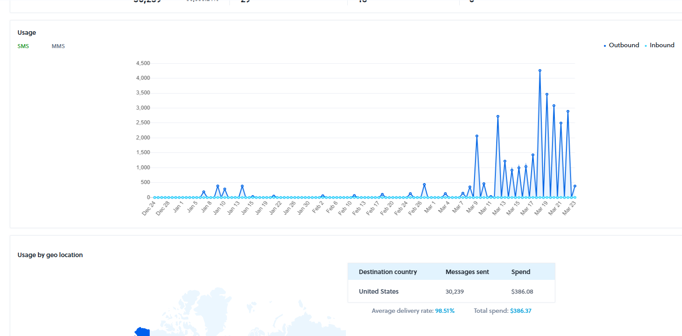
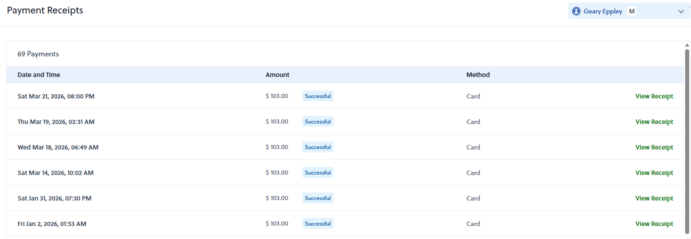
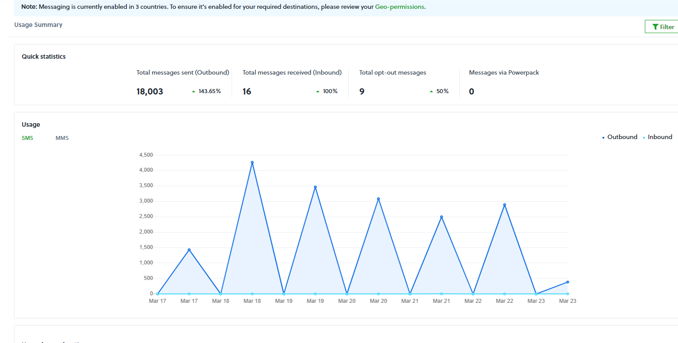
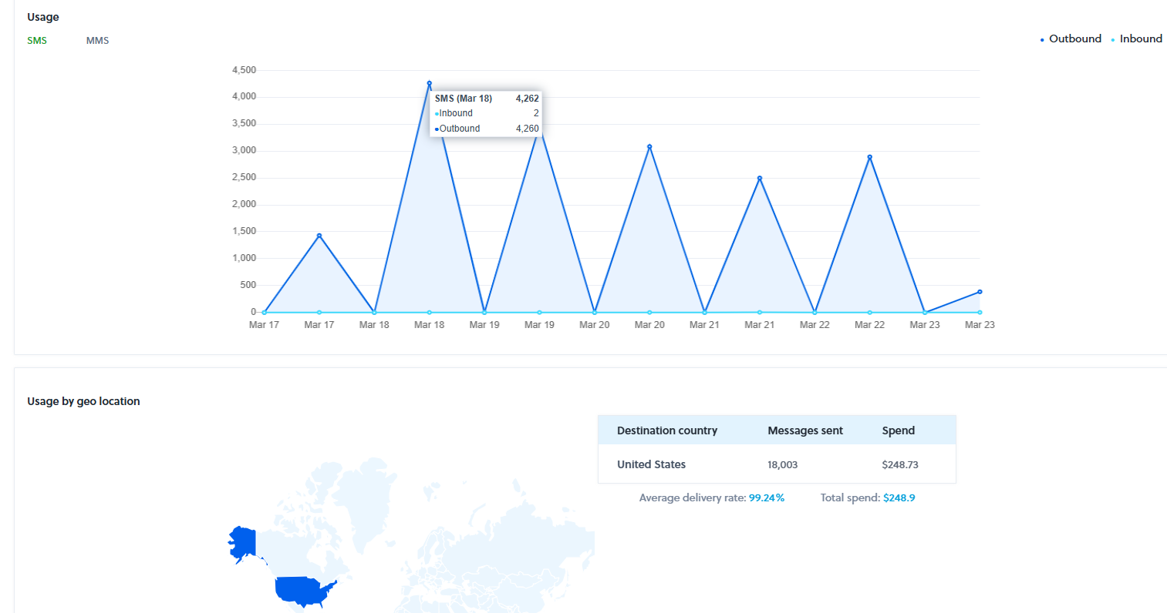
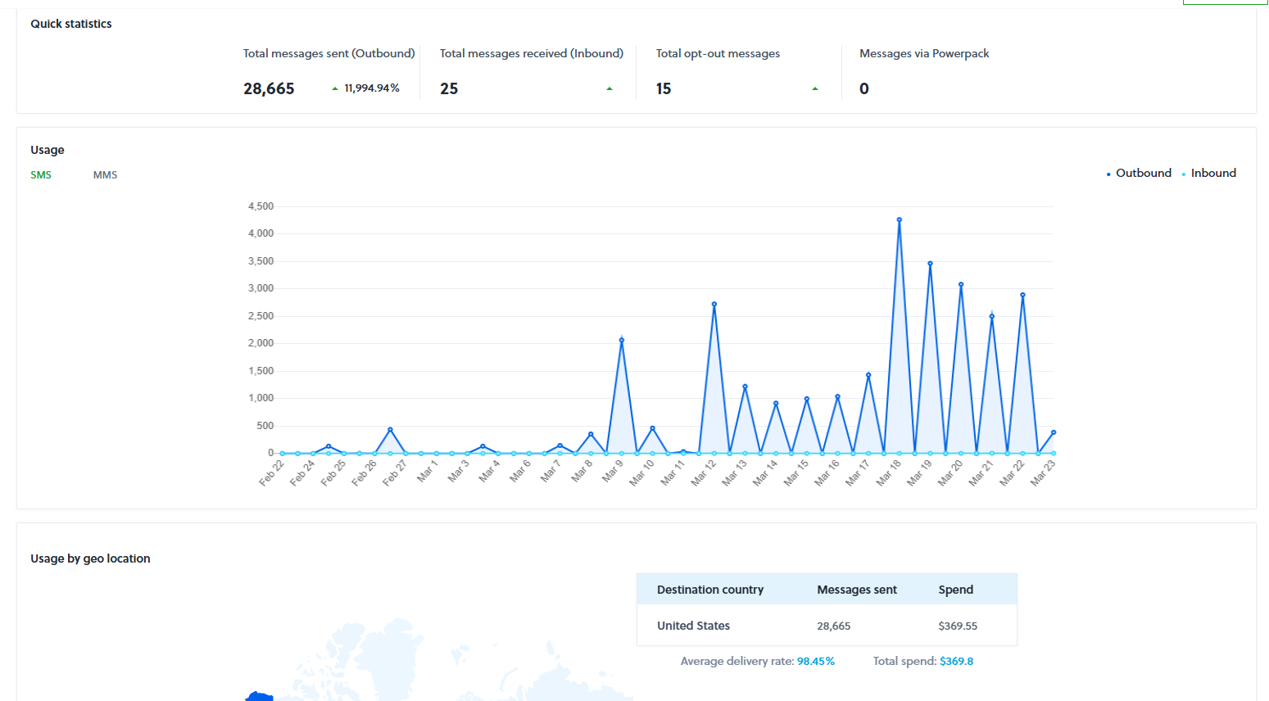

NWRFC Prediction Details
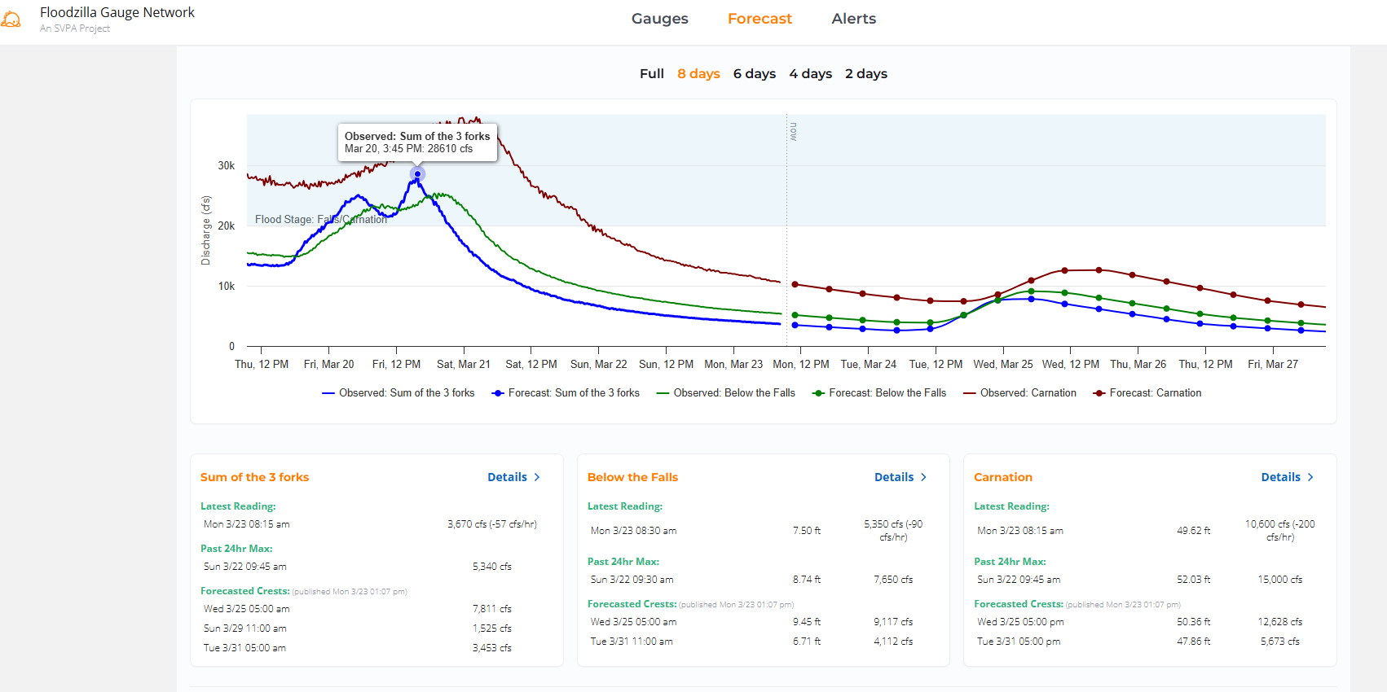

Gauge Specific Details
SVPA-37 Snoqualmie Falls Golf Course
This gauge experienced an issue with the Status Change Data being off by a few inches. This is most likely because we edited the data earlier in the year to account for a wide detection cone with the new sensor brand, Milesight.

SVPA-36 Fall City – Neal Rd. SE
This gauge experienced no problems.

SVPA-34 The “T” at W Snoqualmie River Rd SE
This gauge experienced reception problems and during the flooding event, Jarvis Keller raised the gateway higher to help. We think that worked. It experienced some debris or issues that had to be monitored near the end via deleting bad data.
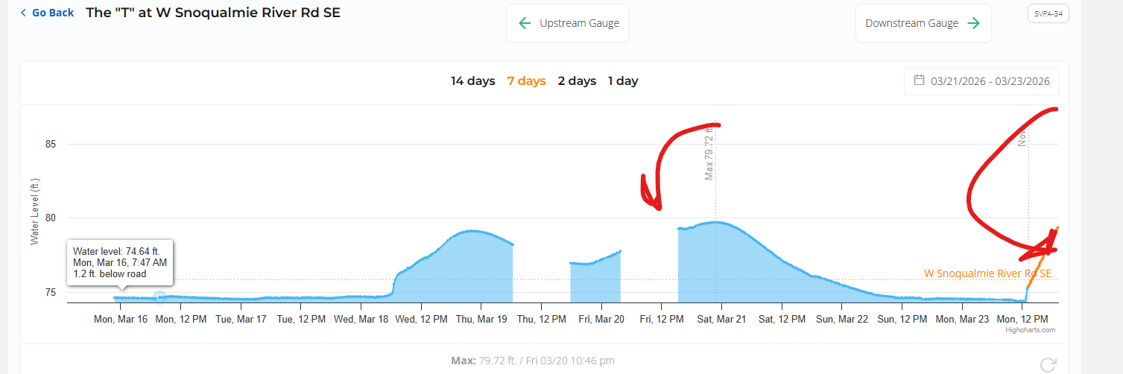

SVPA-33 Snoqualmie River at SE 19th Way
At the site, both the posts for the platform were damaged/removed. The platform itself is still stable and attached. The benchmark is loose but still there.

SVPA-29 W Snoqualmie River Rd NE near Jubilee Farm
This gauge experienced no problems.

SVPA-26 W Snoqualmie River Rd NE at Blue Heron Golf Course
This gauge experienced no problems.

SVPA-25 Snoqualmie River at NE Tolt Hill Rd
Some major gaps in data transmission, which needs to be improved. We did not capture all the events when the water went over the road.
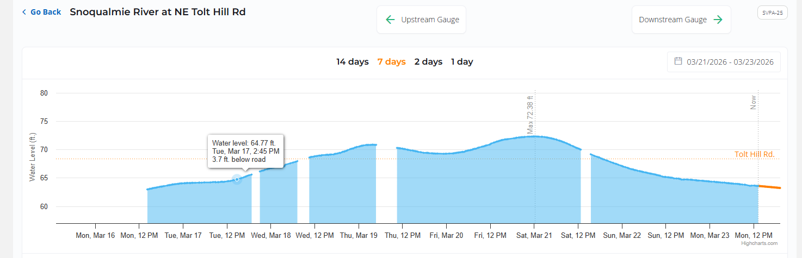

SVPA-19 Stuart Landing - South of Oxbow Farm

No major issues with this gauge.

SVPA-17 NE 100th St at Goose & Gander Farm
No major issues with this gauge, although it would be better in the long run to move it to the other side of the road to capture when the water begins flowing over the road.

SVPA-15 NE 124th St (east at Local Roots Farm)
This gauge experienced gaps in data during the flooding most likely due to radio signal strength.
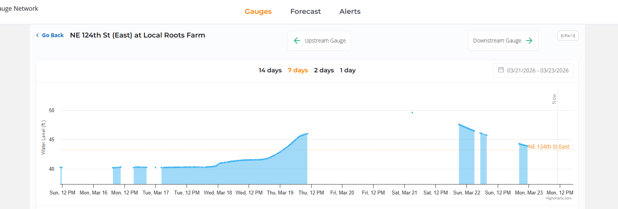

SVPA-15B 124th St West
There were some significant gaps in data that would have been nice to have during the flood. We missed sometimes where water went over the road and we don’t know why the data wasn’t transmitted. Most likely we need to improve the reception. We even tried pressing the reset button before the flood but that didn’t help. We think it is due to this whole cluster experiencing issues with reception.
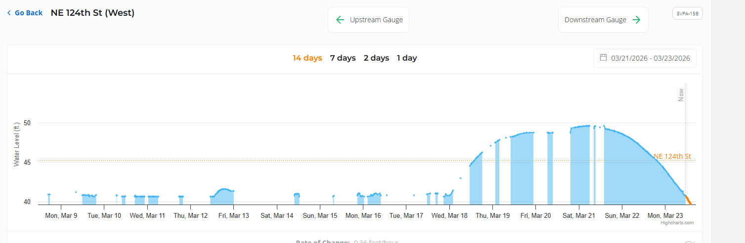

SVPA-12 138th St
No major issues with this gauge.

SVPA-6
Turned off.

SVPA-6B
Turned off.

USGS gauges:
USGS-SF17
USGS-MF11
USGS-NF10
USGS38
Gateways and other equipment:
No major issues with the gateways during the flooding event, other than someone readjusting the height of the Tall Chief gateway for better reception. In general there is a lack of gateways to support the network that we would like to bolster.
Other experiment going on at the time:
In March we set up a spare gateway in the barn 2nd Story because the one on top of the barn stopped working. It does not connect with the original gauges as well as the one on top of the barn, which we believe reduced the reception.
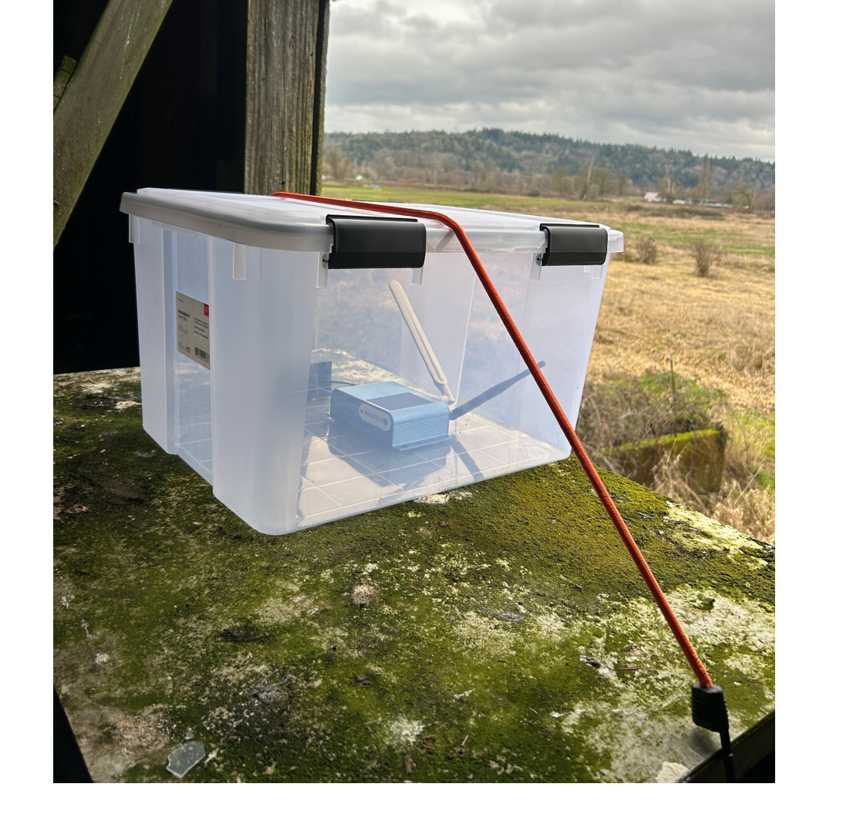
Other numbers
- Approximately 18,000 SMS text messages sent between March 17th and March 23rd
- Approximately 3,000 iOS app downloads for all time
- Approximately 400 Android app downloads for all time
- 1,170 users signed up, a 1.9% increase from January numbers
- The Floodzilla interactive map processed 9,753 Maps Javascript API requests during the reporting period of March 10th through March 24th, reflecting active user engagement with real-time flood monitoring tools.
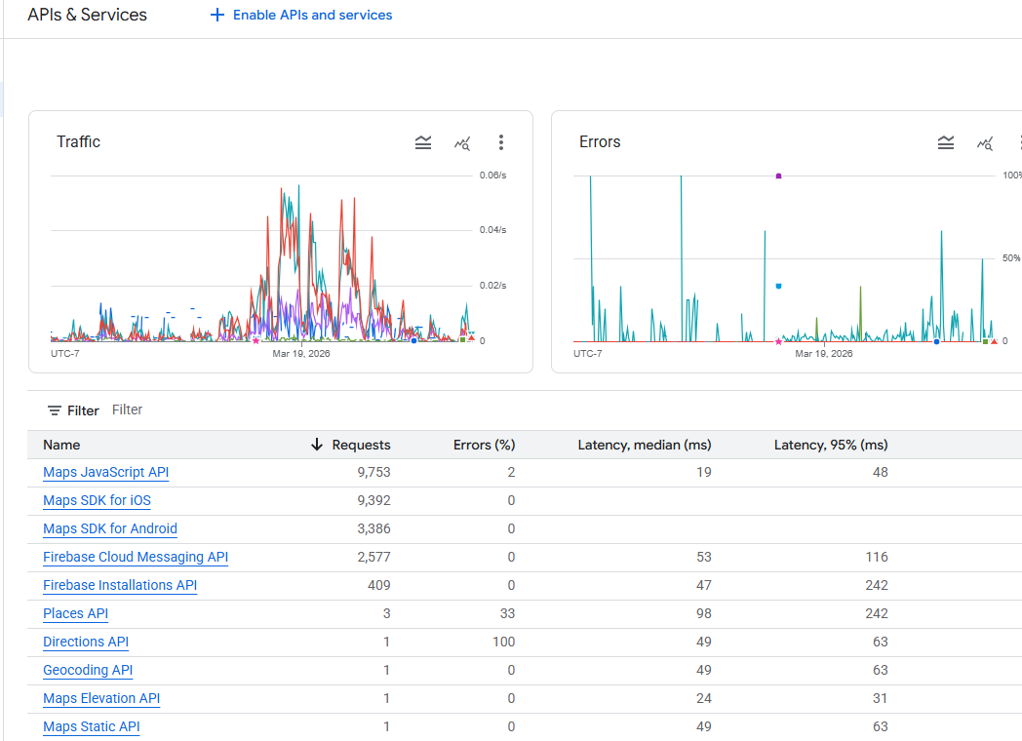
Screenshot of Google Console data under APIs and Services tab.

Actionable follow up Items
Gauge Site-Specific actions:
Site inspections:
Gateway Specific actions:
In the summer we will need to prioritize some sort of transition for the cluster of gauges and the gateway at Goose and Gander farm. This will include bulking up gateway/gauge inventory with the public lorawan programming. We will also need to add more gateways within range of those gauges so that they don’t all depend on one gateway.
Other Flooded Areas:
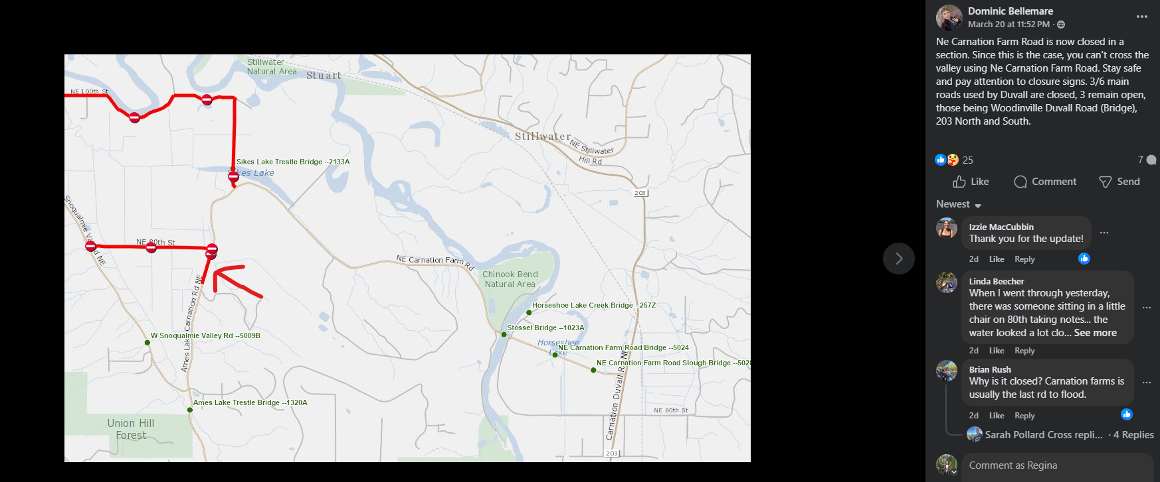
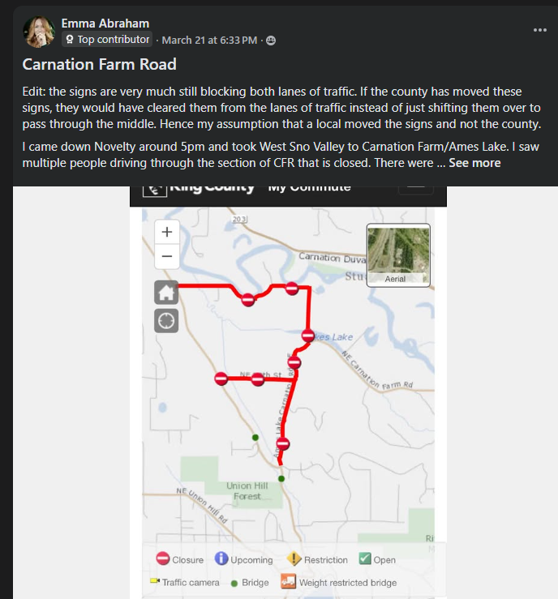
The road also flooded between Duvall and Monroe along 203 and they had to close the road.

Questions and Comments from the Public
One comment came in that the SMS text alerts did not match the website data on the forecast page, but we could not replicate it. Another comment came saying that there had been gaps in data in the T gauge, but at the time the only thing we could do was wait for someone on site to take a look for disruption to line-of-site and adjust the gateway (which someone did do and helped fix the problem).

Social Media Engagement
Before the flood, based on feedback from a user feedback study and meetings with the Fish Farm Flood Flood caucus, Floodzilla Program Manager worked on two outreach/education opportunities. First was a Valley Record article to remind people not to drive in floodwater: https://www.valleyrecord.com/2026/03/12/snoqualmie-river-sees-road-closures-in-flood-phase-2/
The second were some facebook and Instagram posts reminding people of how the King County Flood Phases work and a reminder to use both the King County Flood Warning Center and their app, and the Floodzilla phone app.
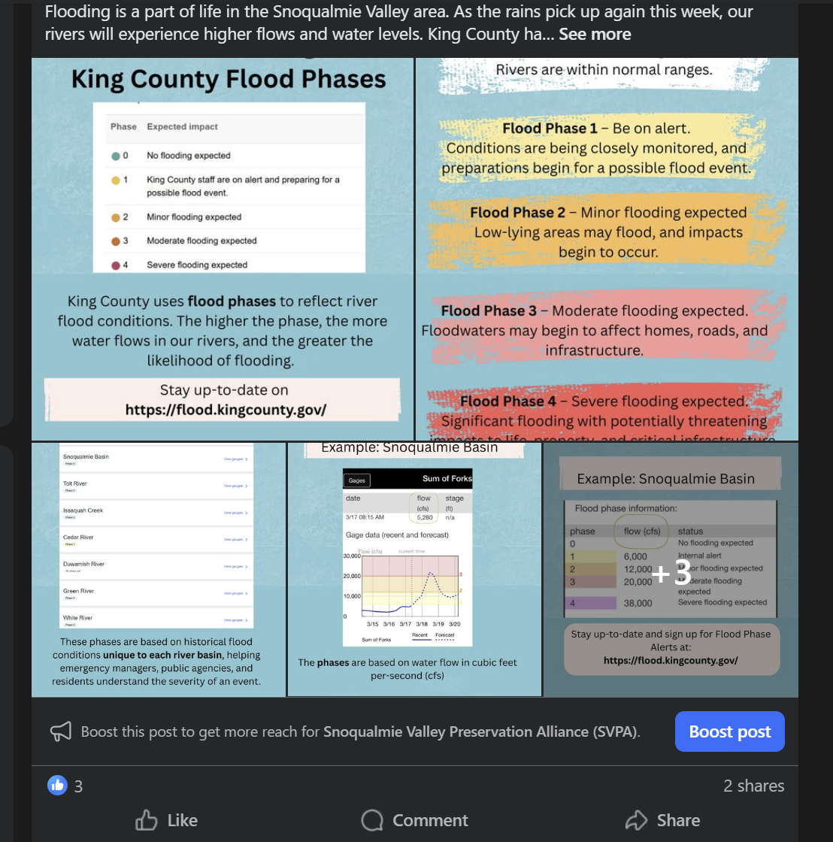
The Floodzilla website was also covered by the Snoqualmie Valley Record on Instagram:
